**-------------------------------------------------------------------------------------------------------------------------------------------------------------------------------------------------------------------------------------------------------------------------------------------------------------------------------------------------------------------------**

**HOW GOOD IS OUR LINEAR REGRESSION MODEL ?**

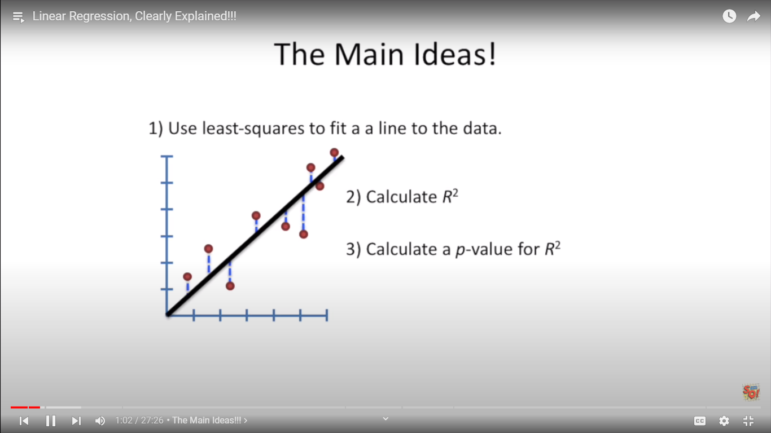

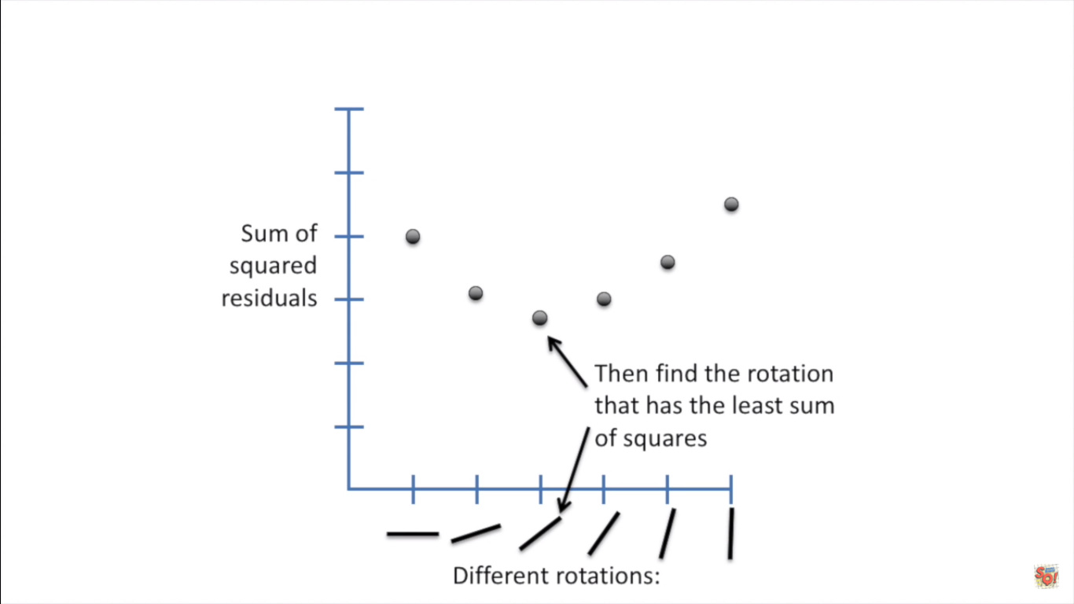

R2 is used to check the accuracy of the model of regression

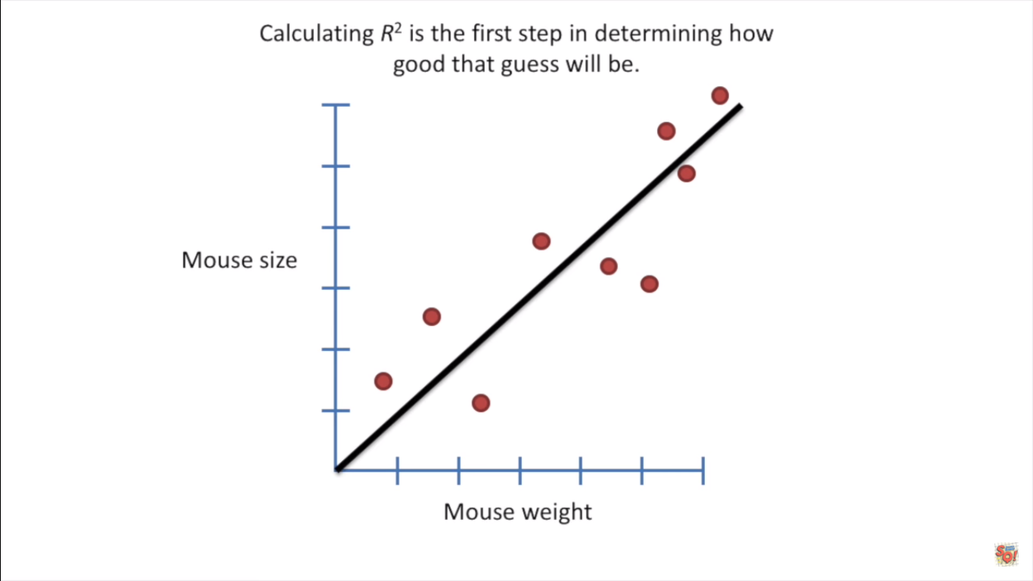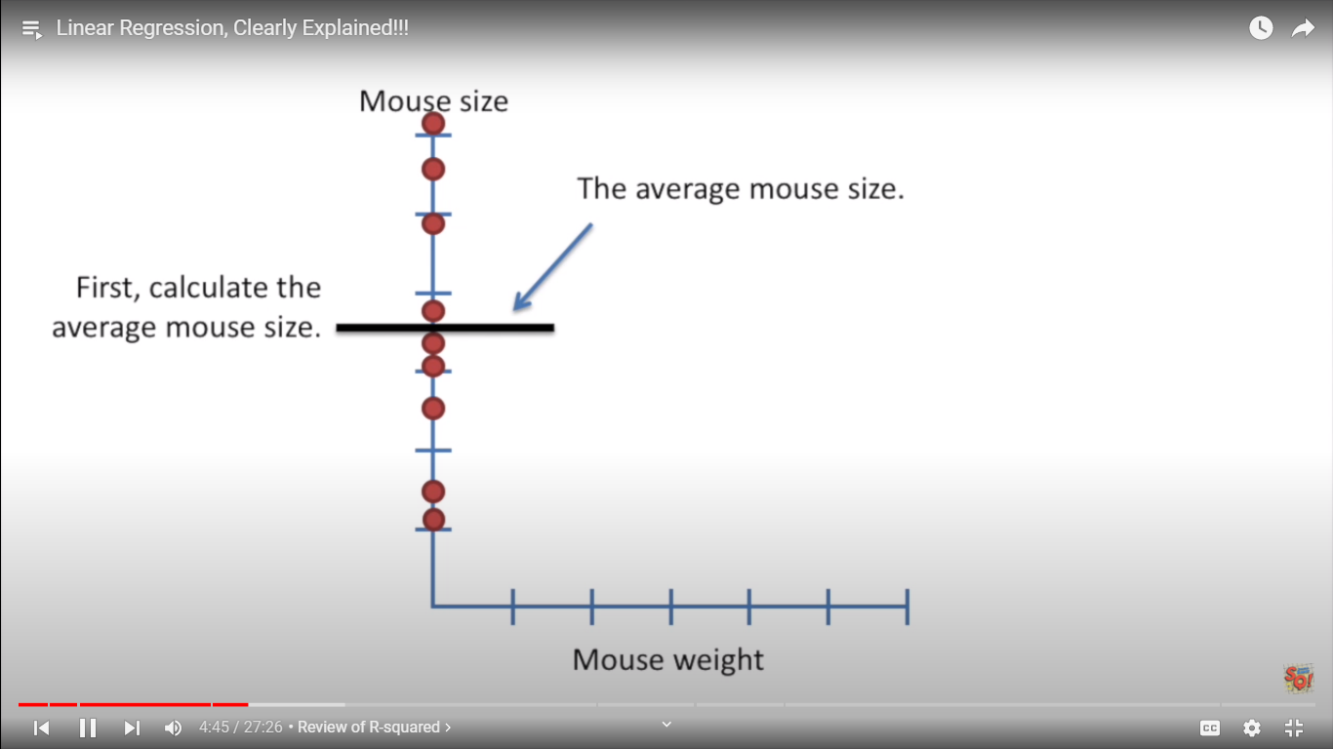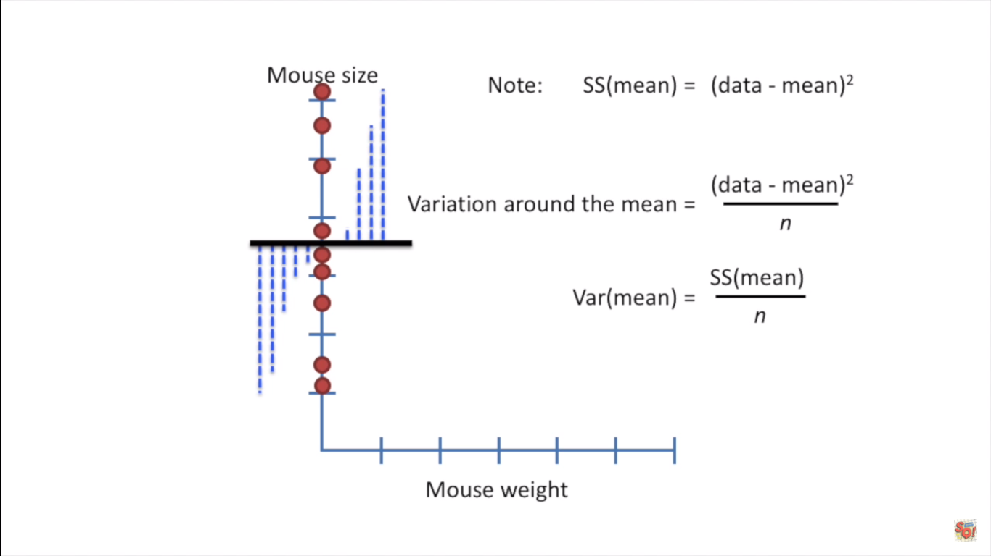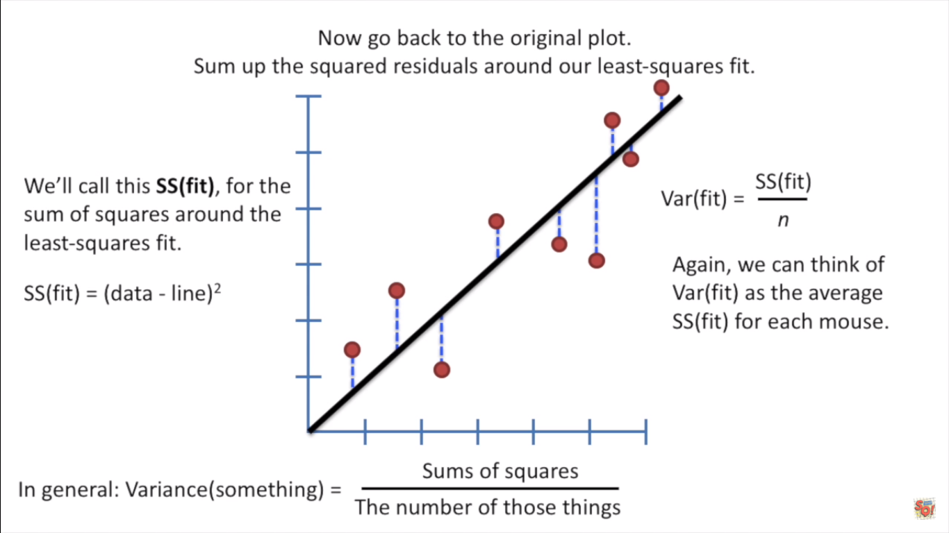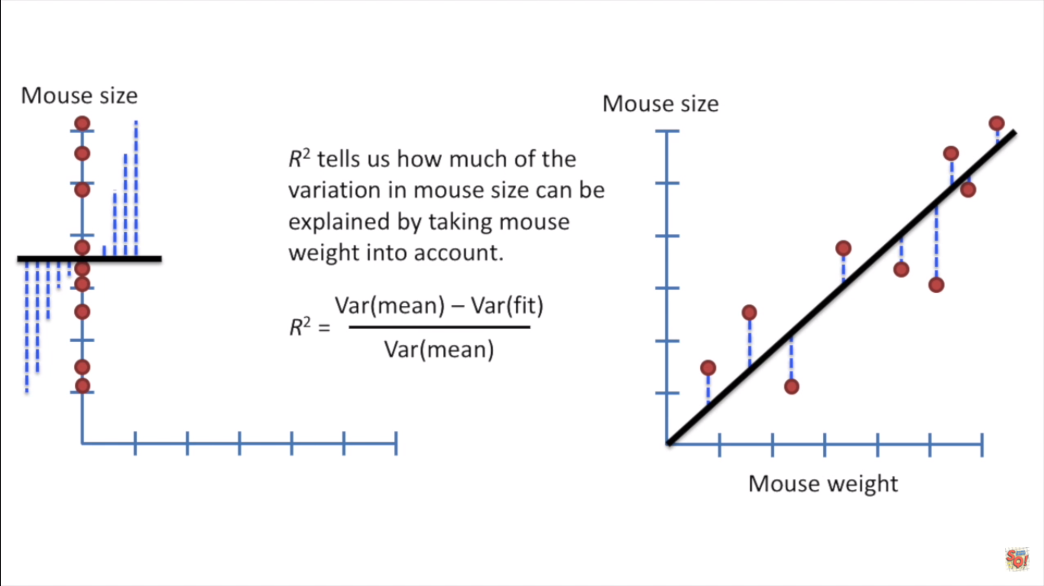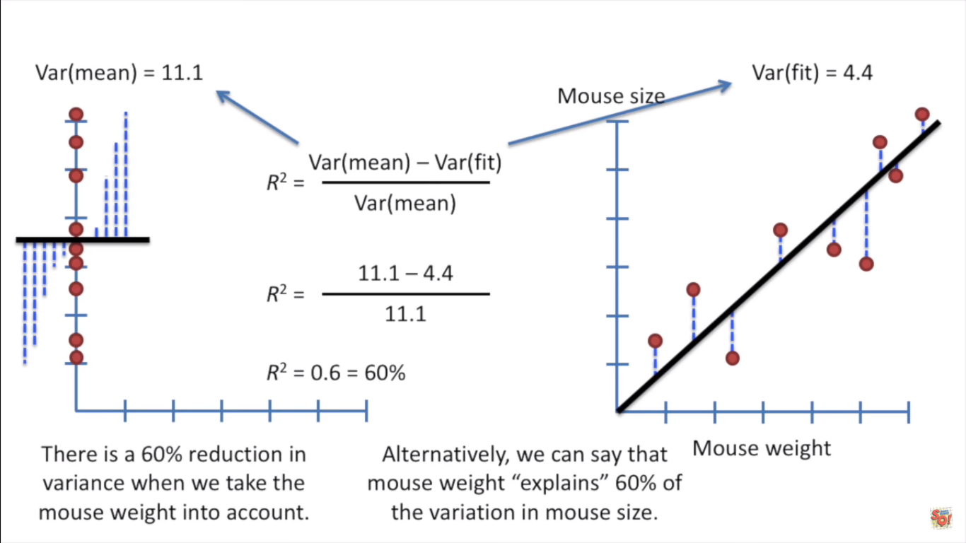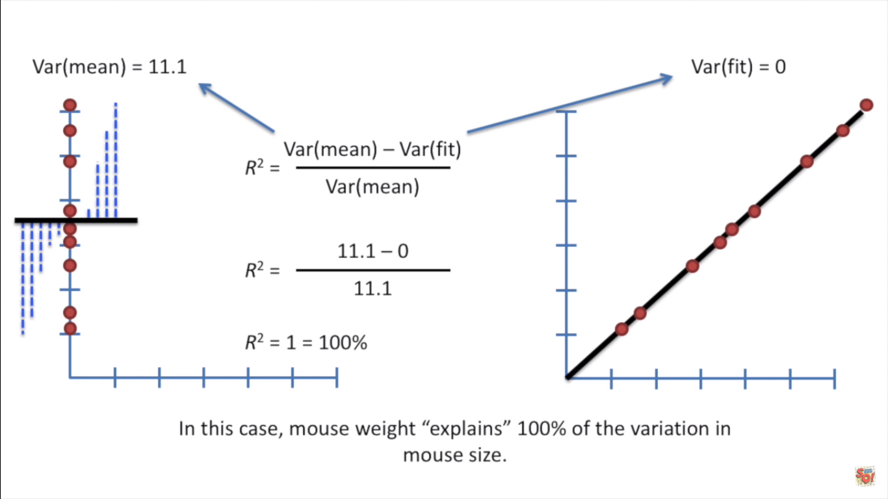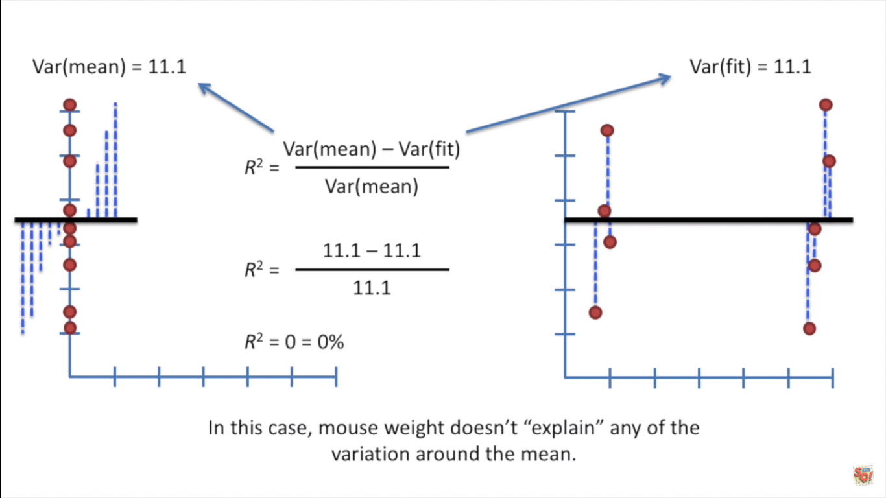

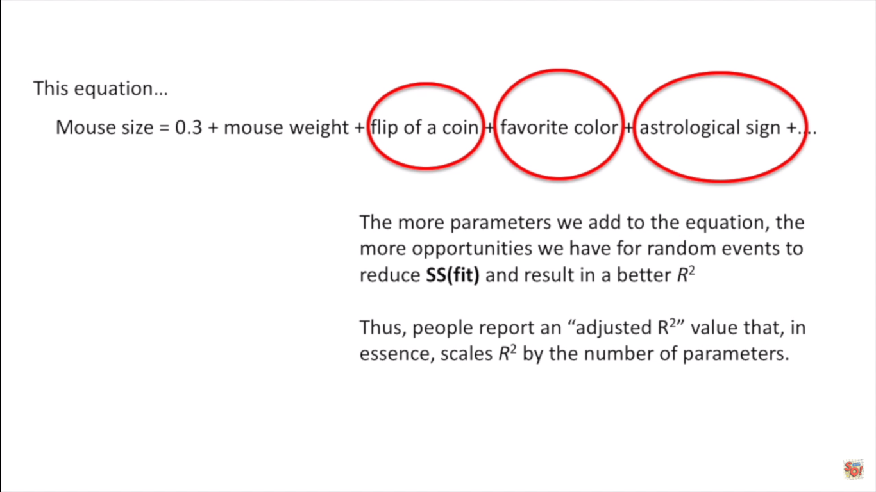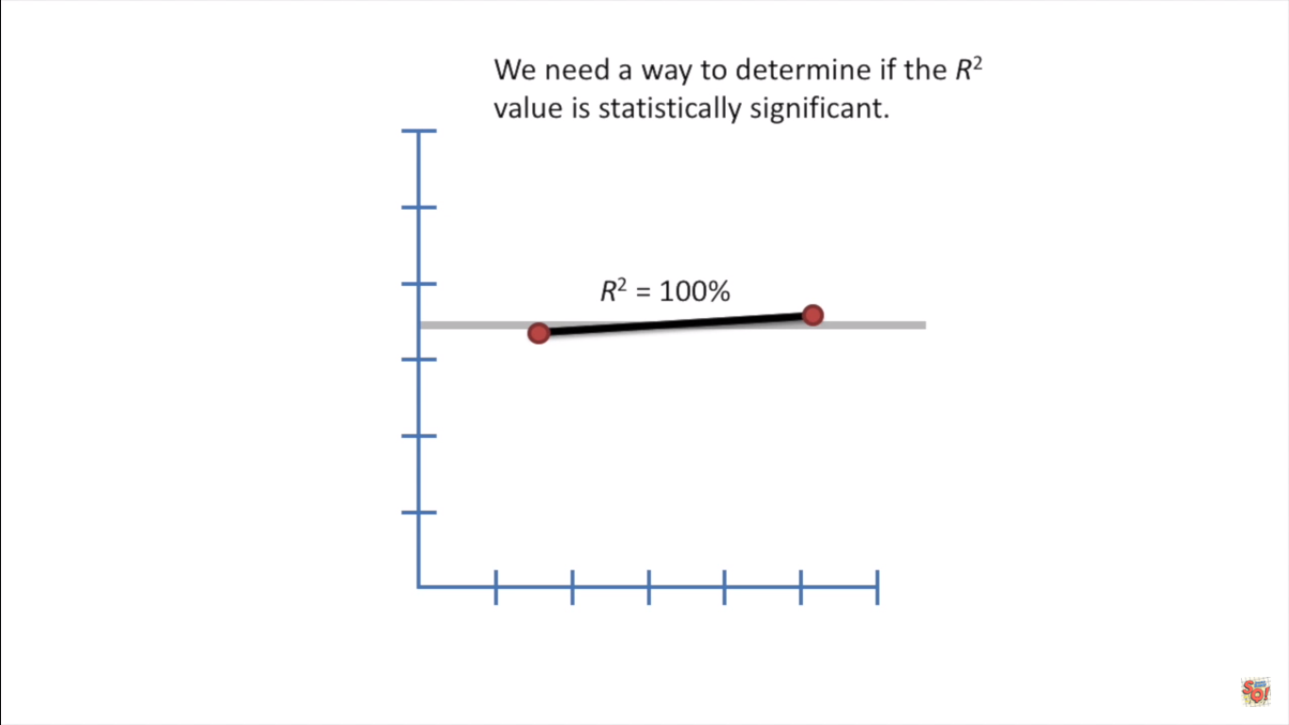

R2 can be negative denoting that the best fit line is even worse than the average line we have

R2 lies btw 0 and 1

R2 increase with increase in amount of features even if the features doesn’t help our model in great way (redundant feature that are not correlated)

So r2 might not be always good

So there comes adjusted r2

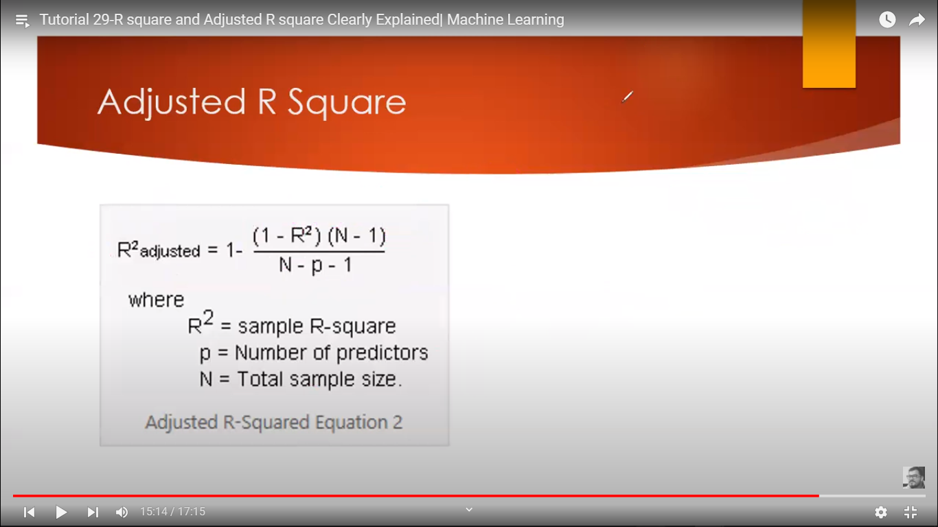 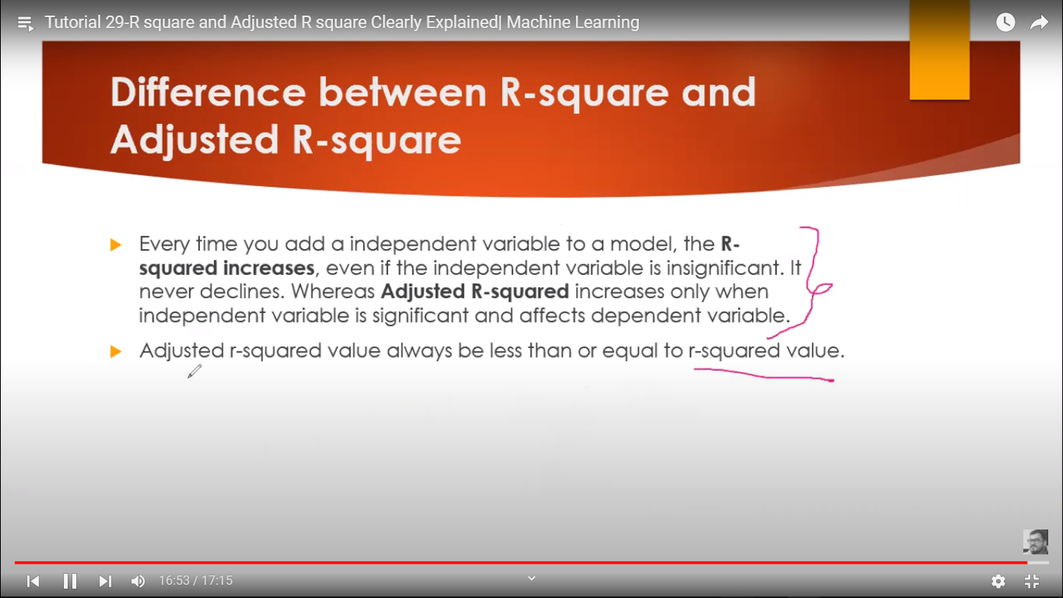

In adjusted r2

If more correlated feature r2 increses with amount of such features

If less correlated feature r2 decreses with amount of such features

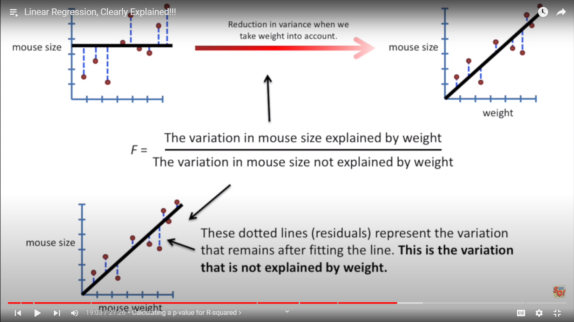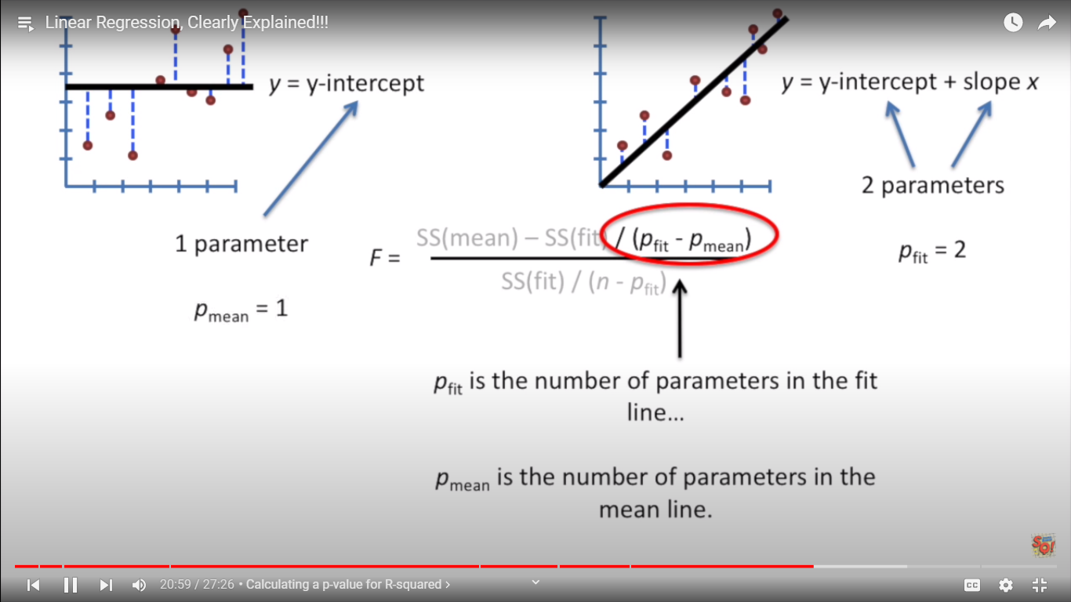

P value is smaller when there are more samples data than the number of parameters / attributes/ feature , and that is what we want .

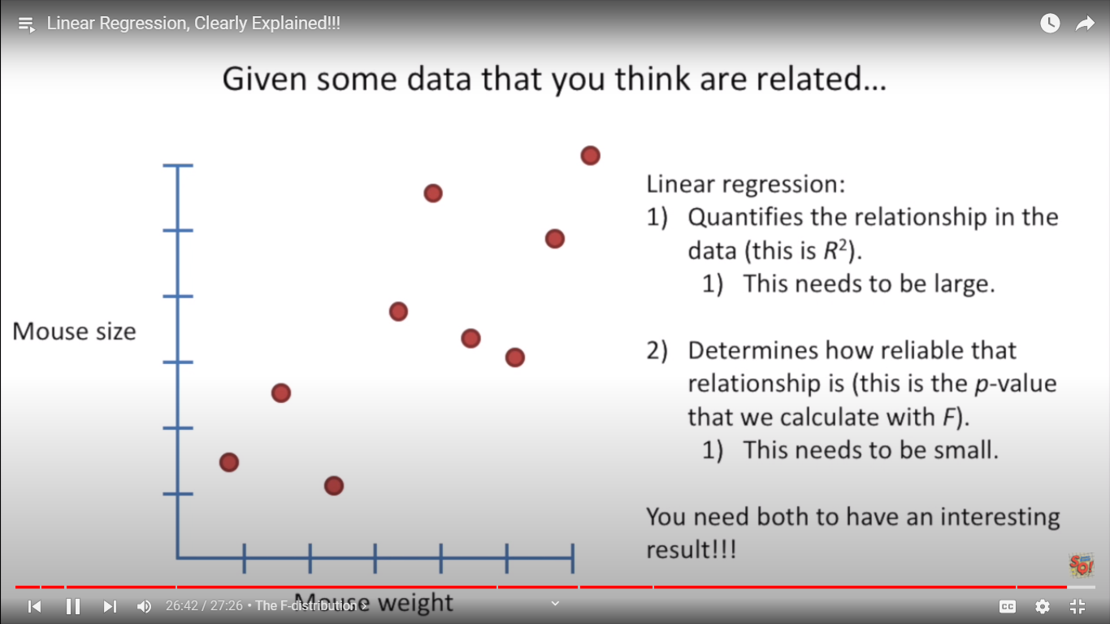

**-------------------------------------------------------------------------------------------------------------------------------------------------------------------------------------------------------------------------------------------------------------------------------------------------------------------------------------------------------------------------**

**GRADIENT DECENT**

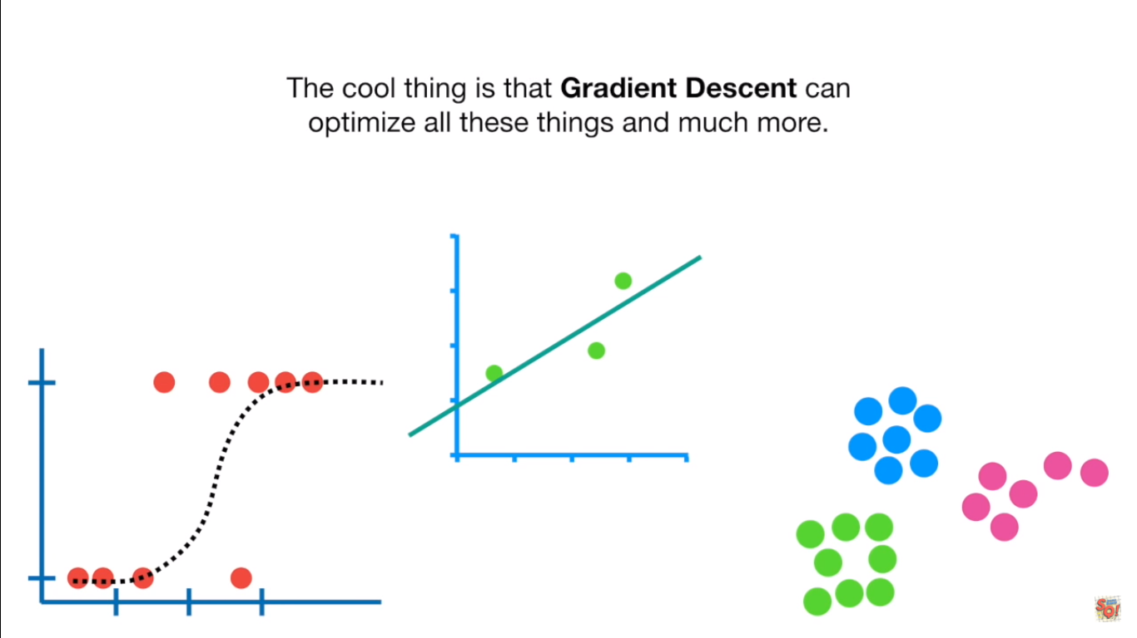

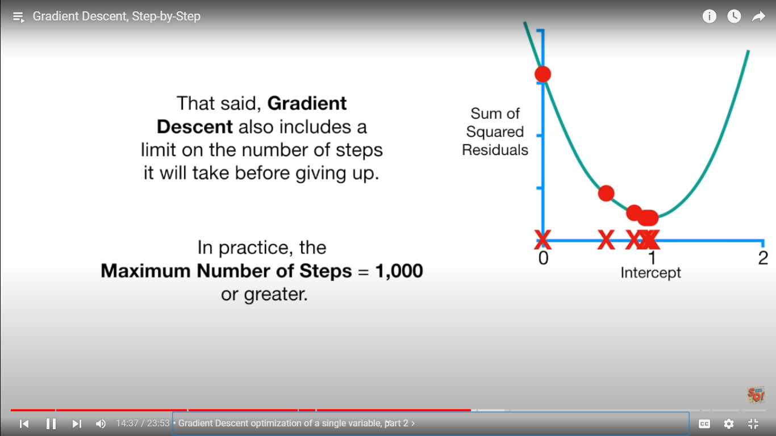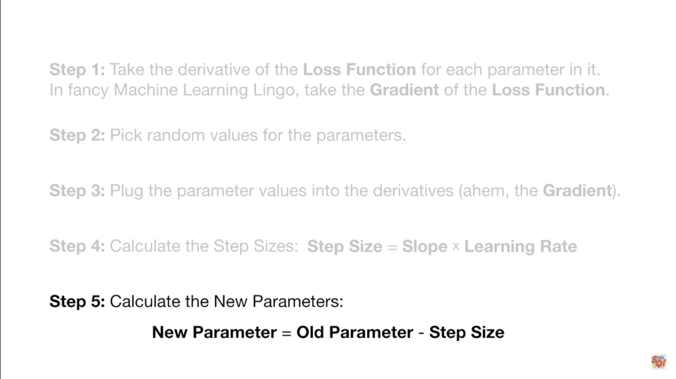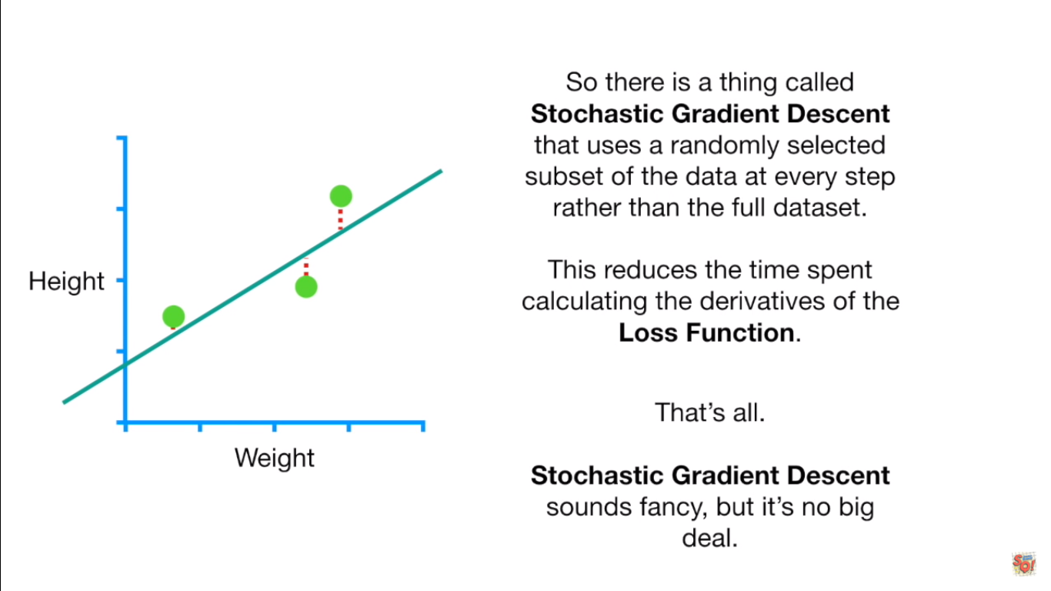

Coursera OP

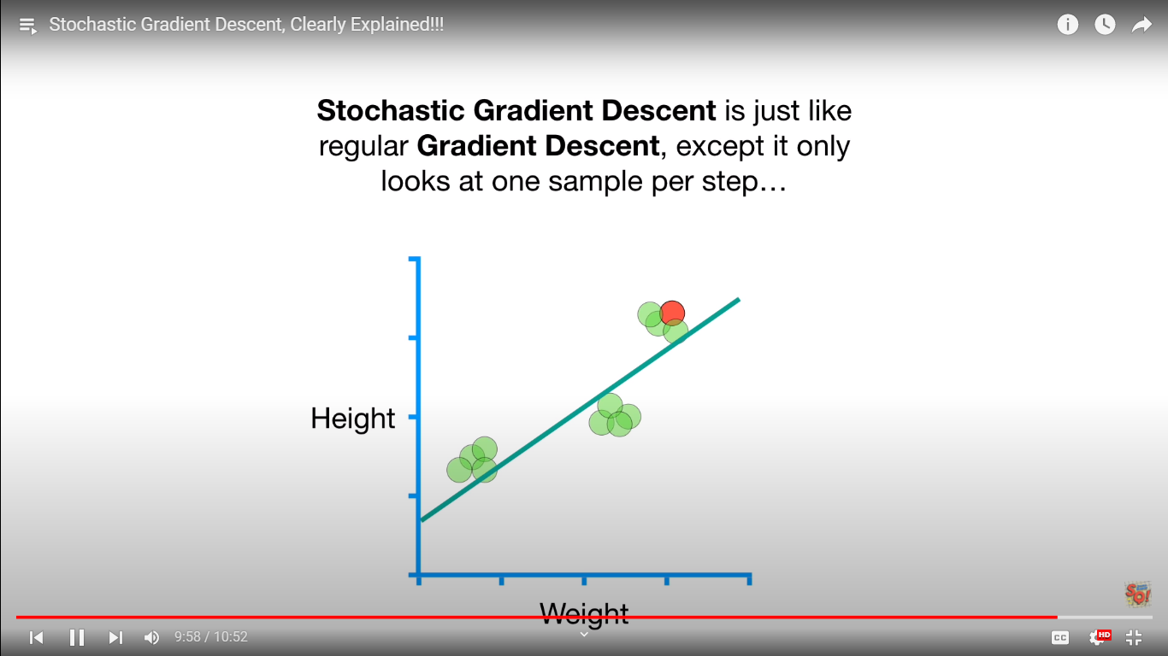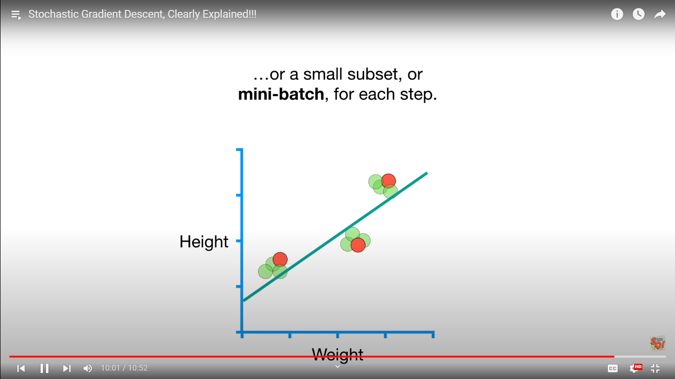

Gradient decent is slow when we have large datasets and lagre no of derevatitve terms, so we use stochastic gradient decent or mini batch .

**-------------------------------------------------------------------------------------------------------------------------------------------------------------------------------------------------------------------------------------------------------------------------------------------------------------------------------------------------------------------------**

**LOGISTIC REGRESSION**

Coursera OP

Odds and log odds

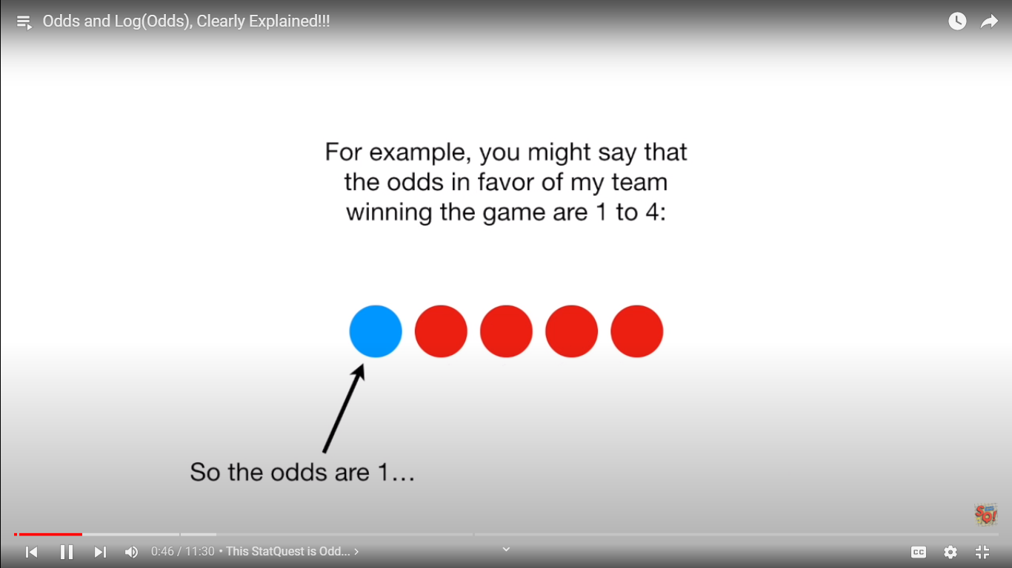

Odds are not probability

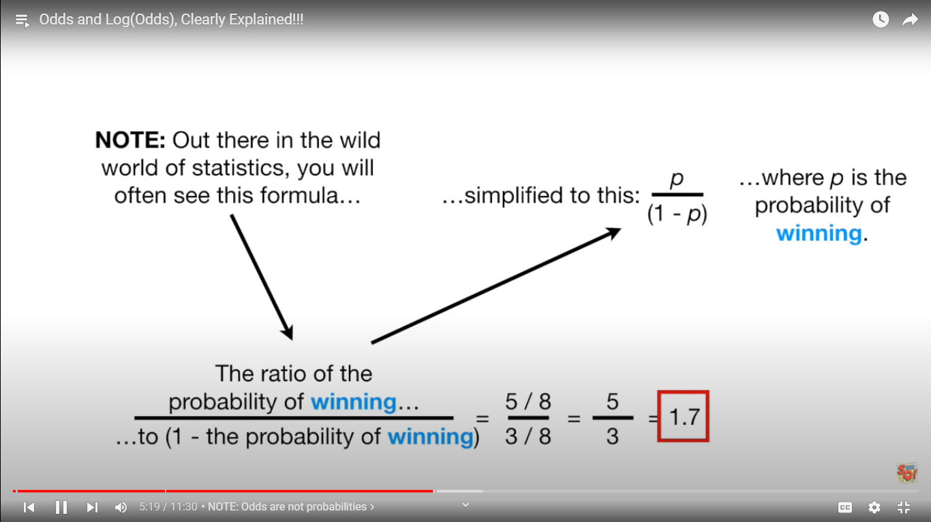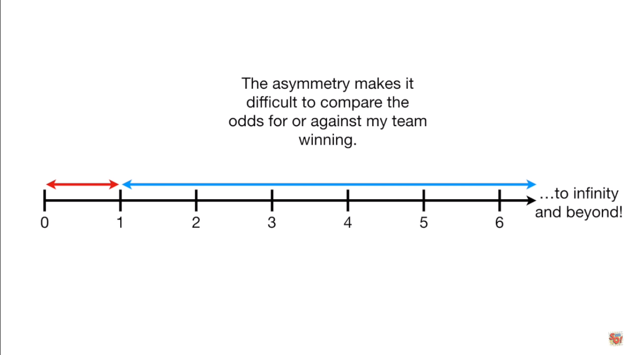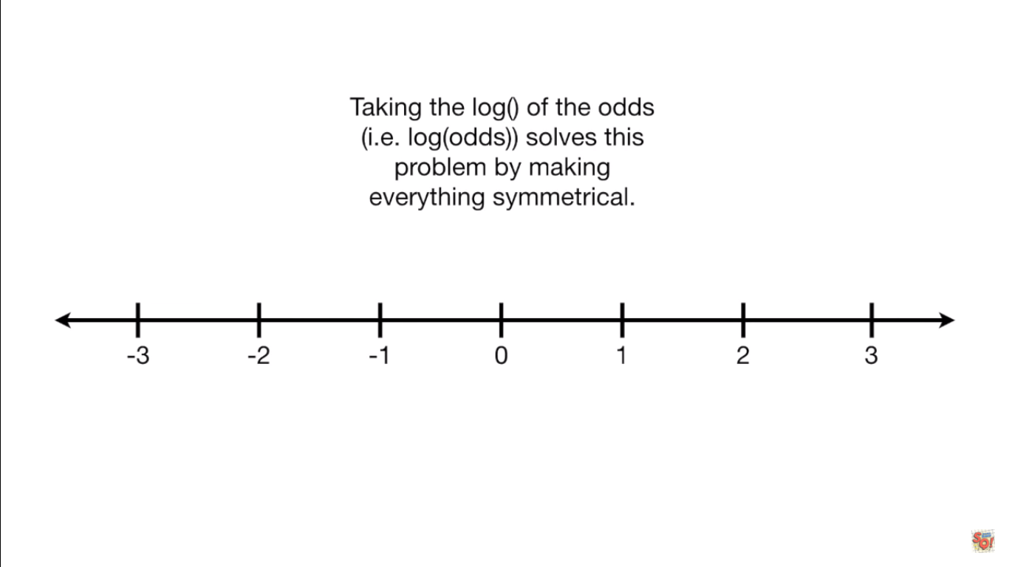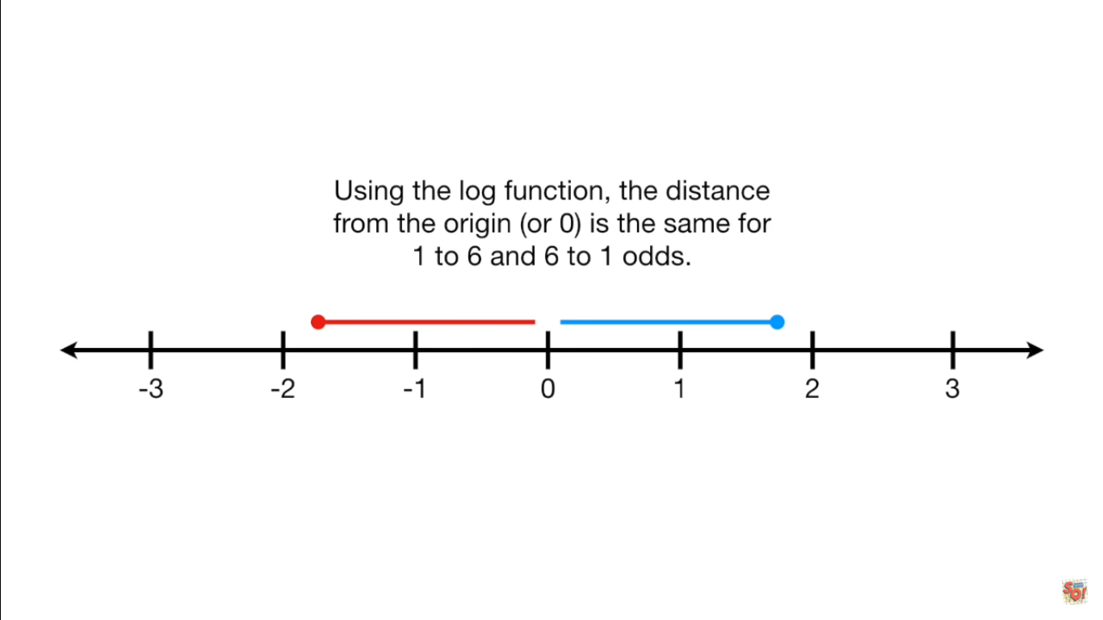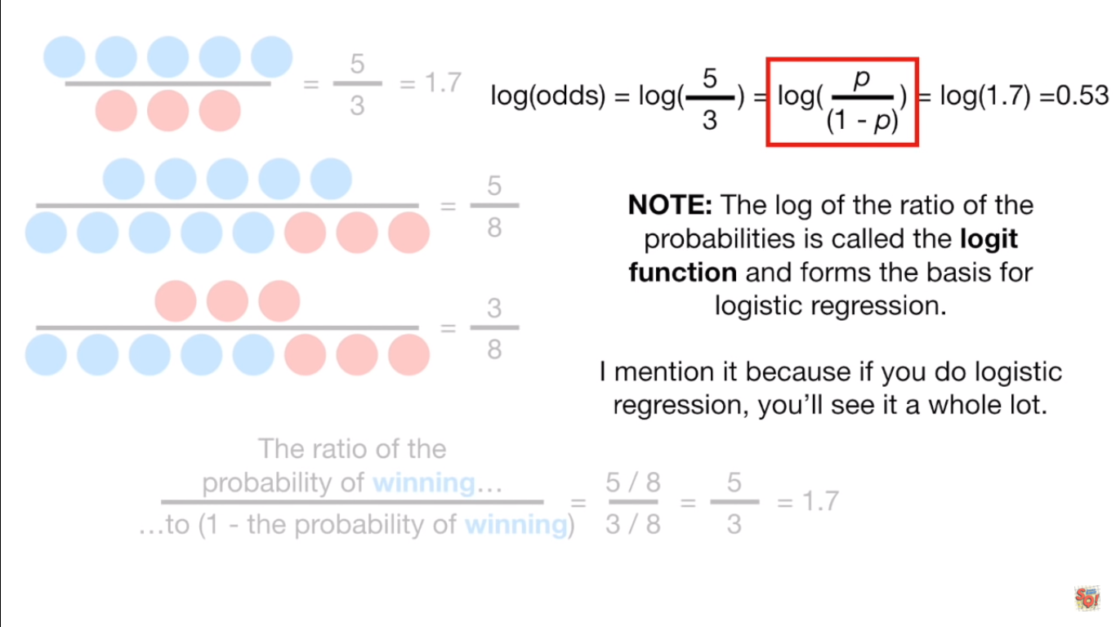

Odds ratio and log (odds ratios)

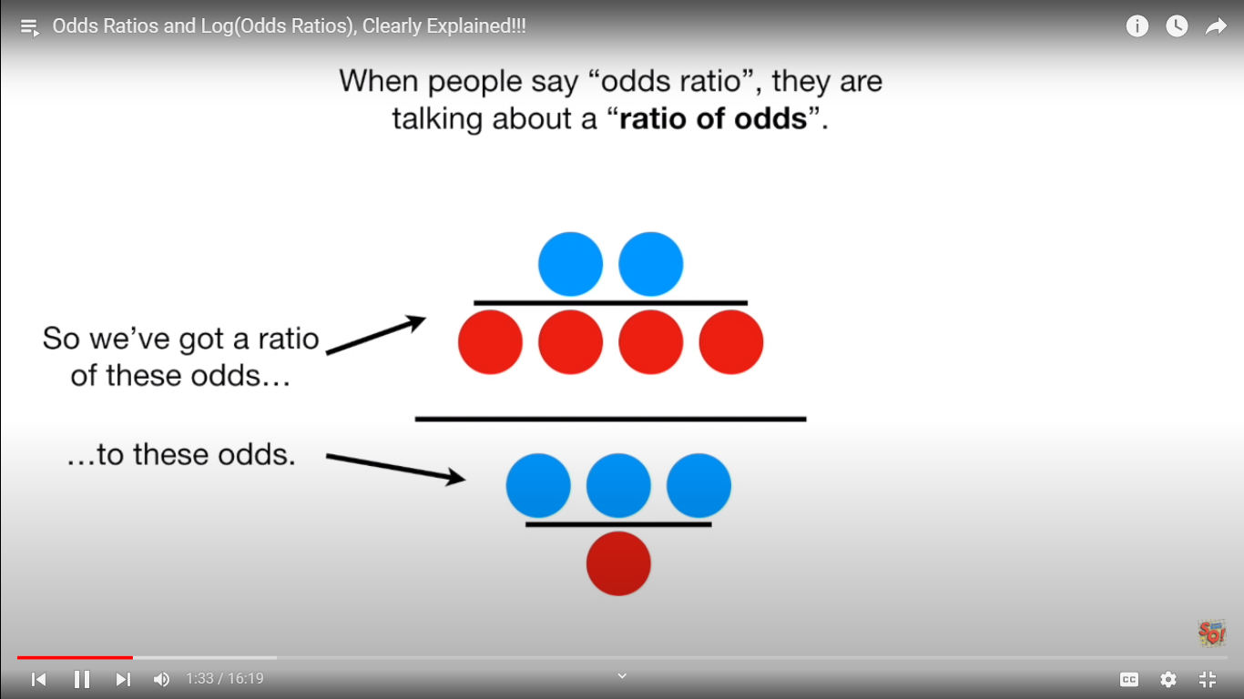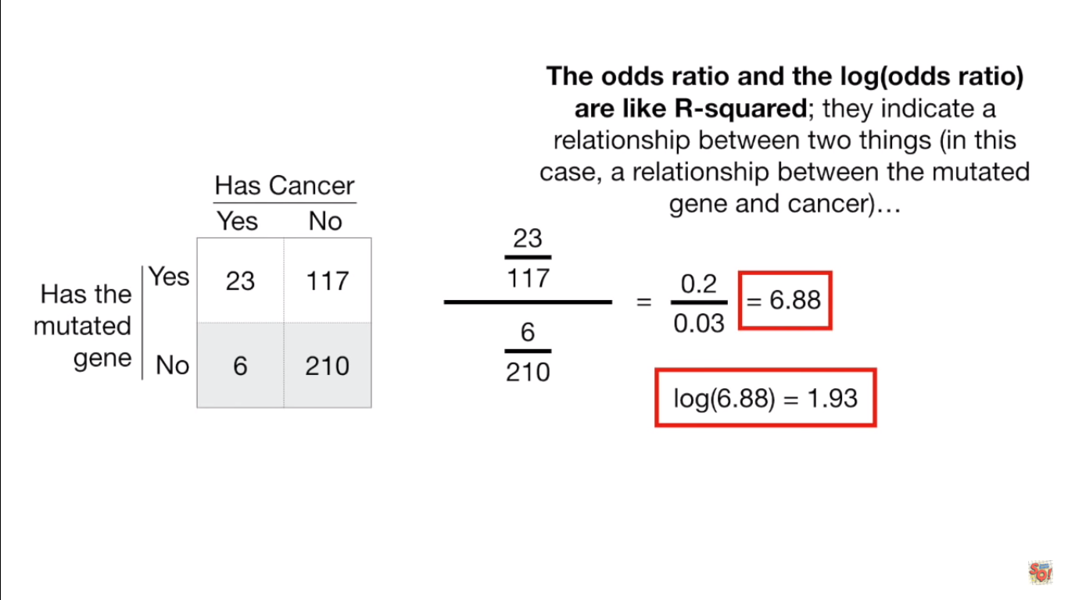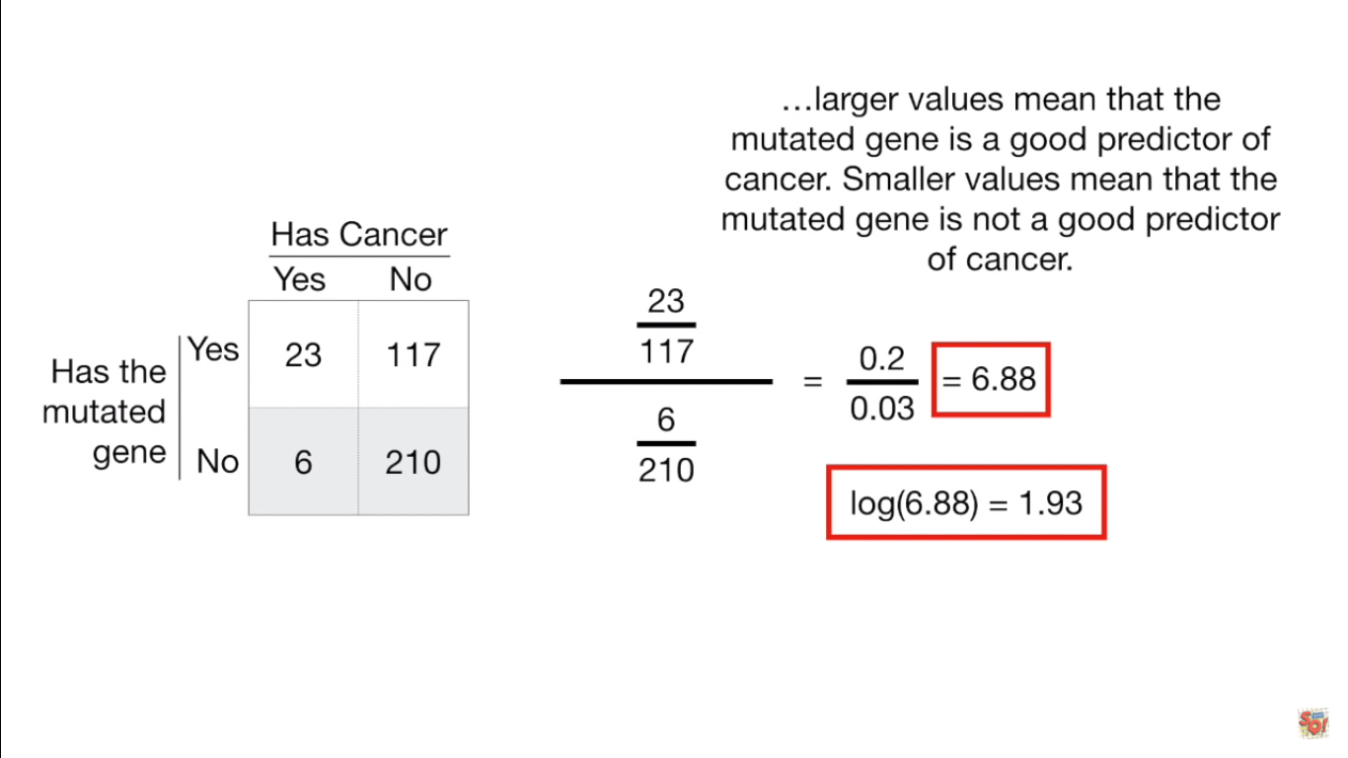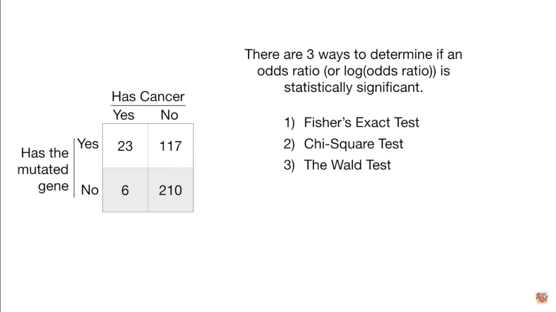

Walts test

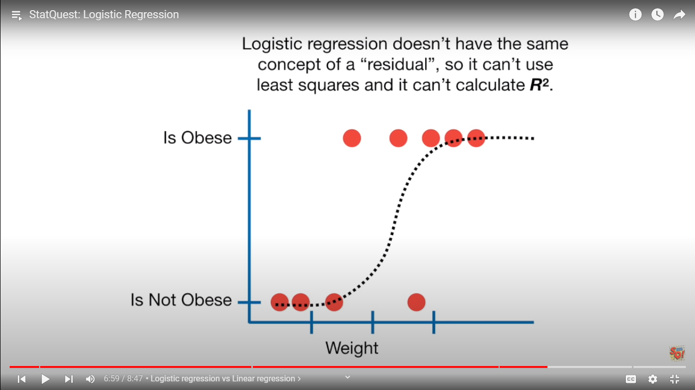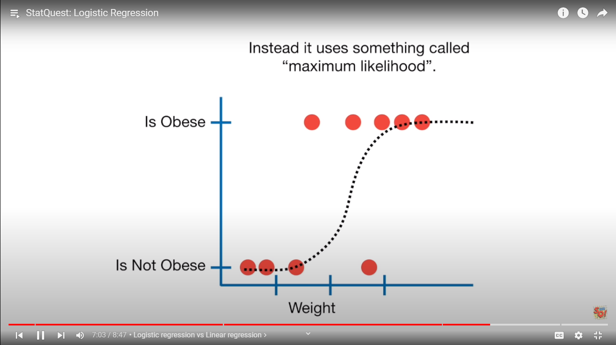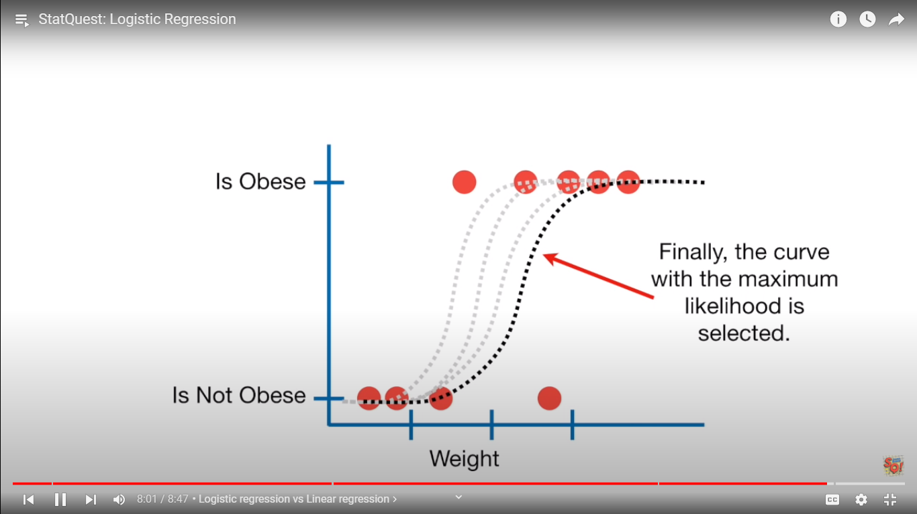

Coeffticents

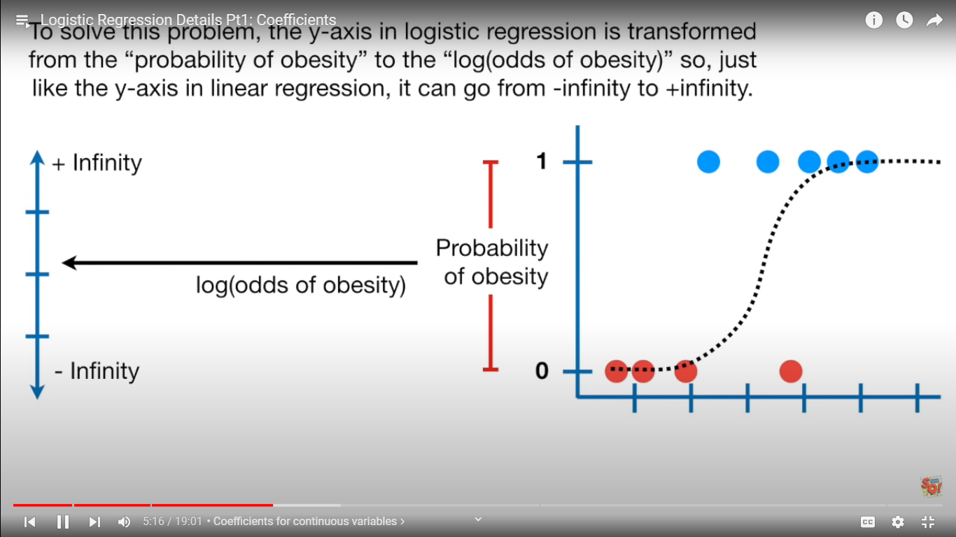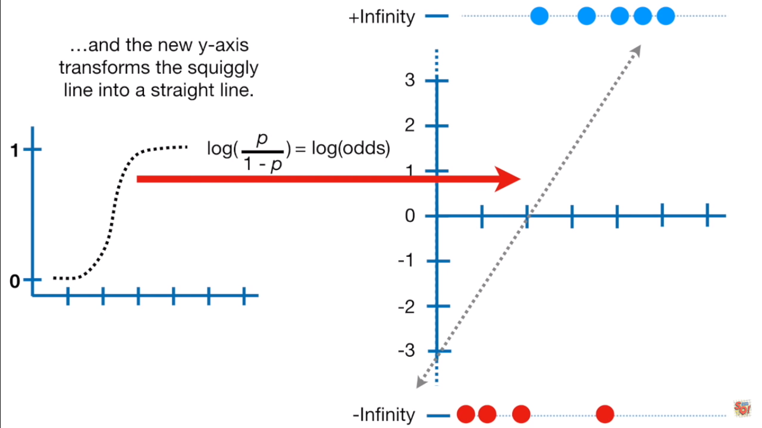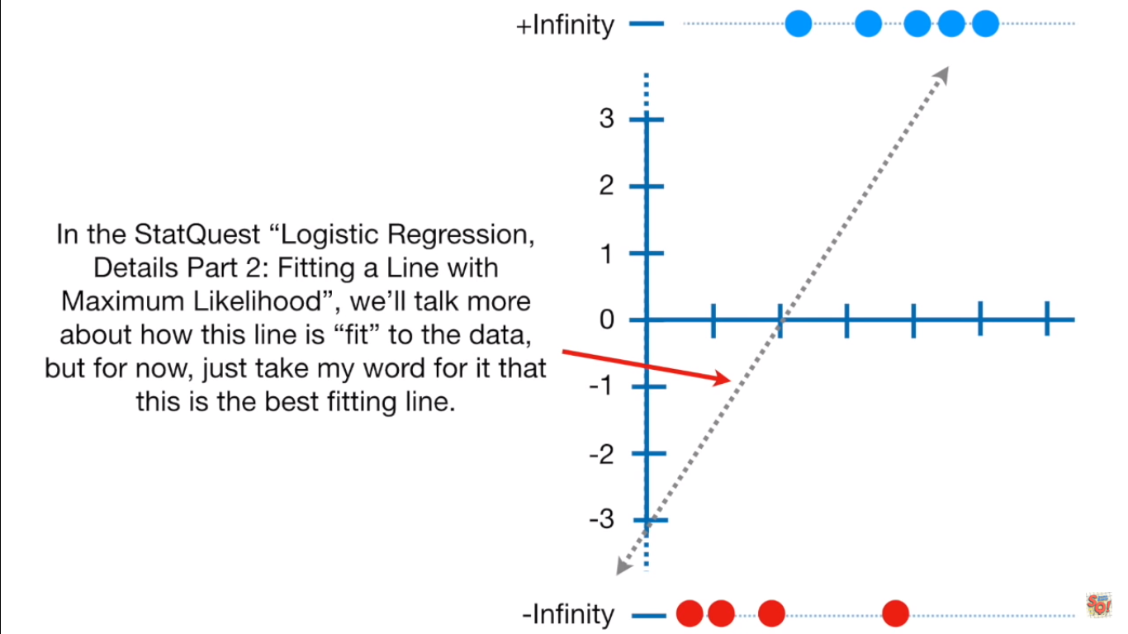

Now we cant use least square methods because the errors can be infinity

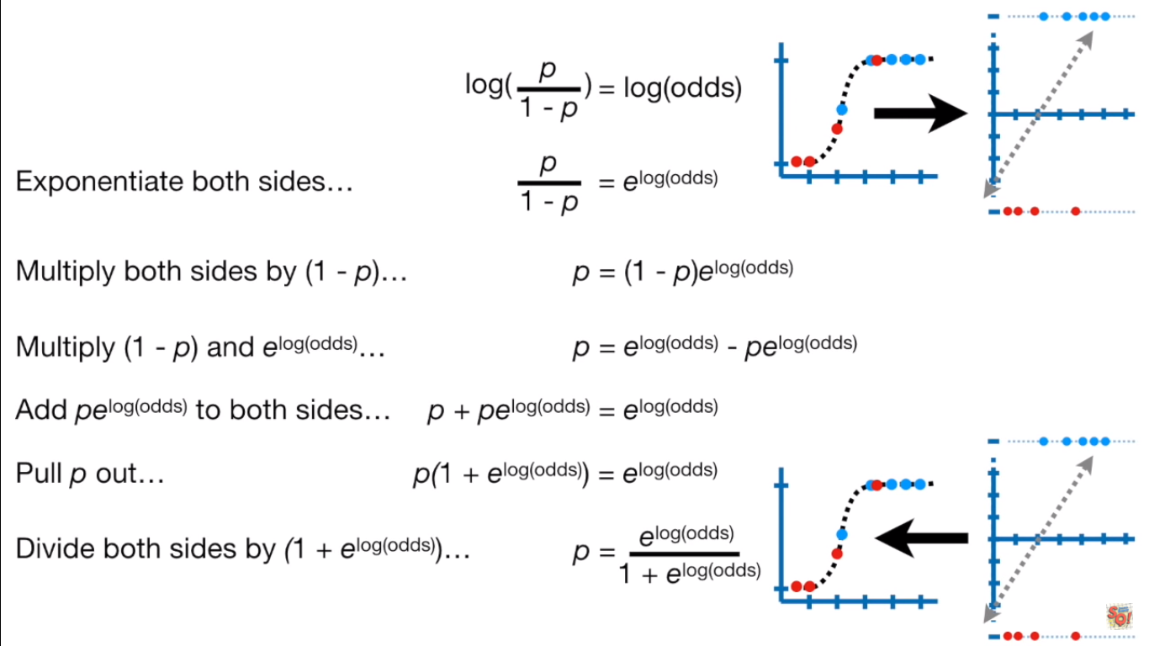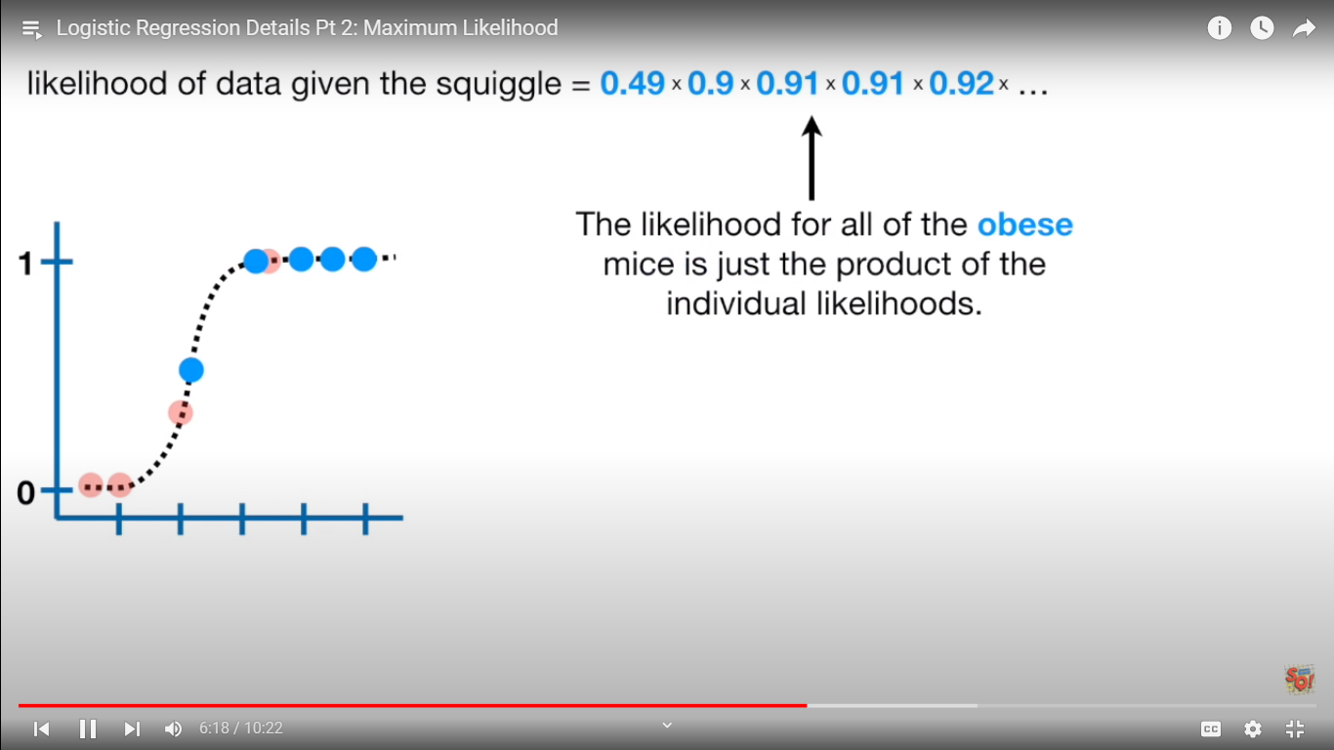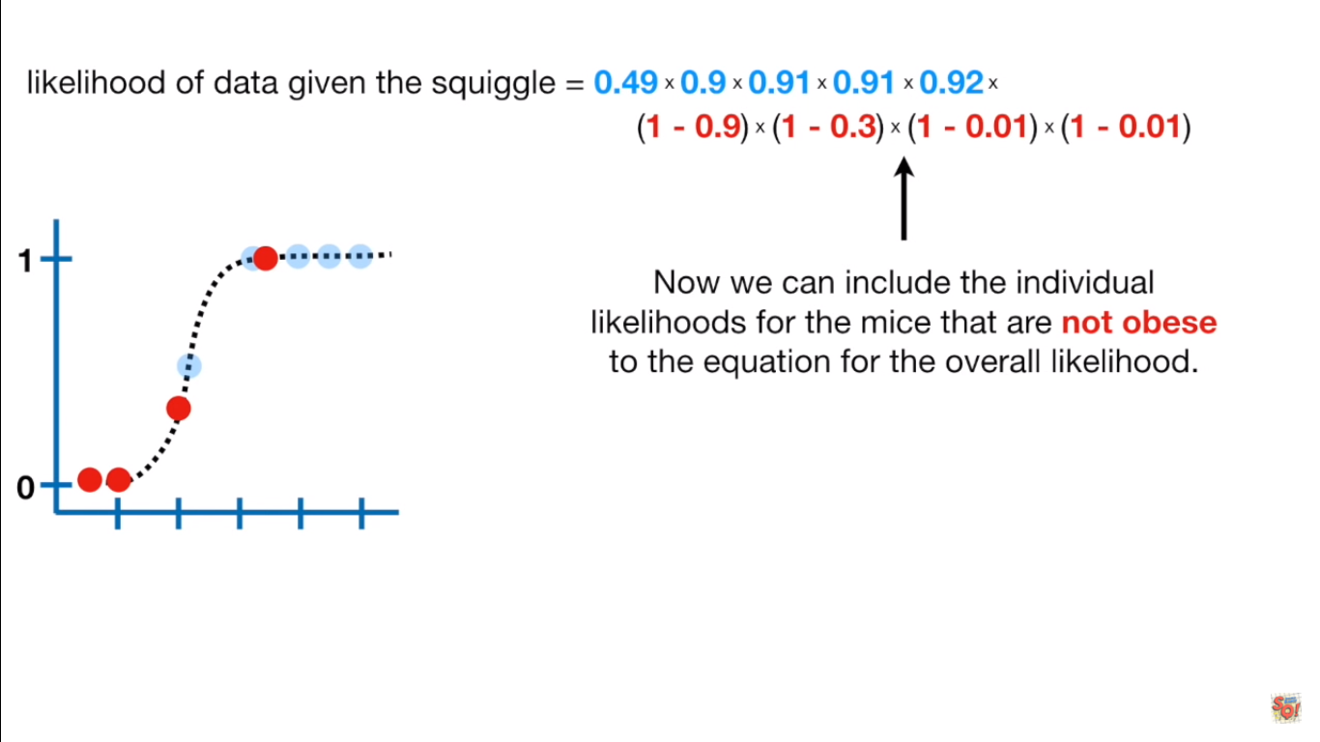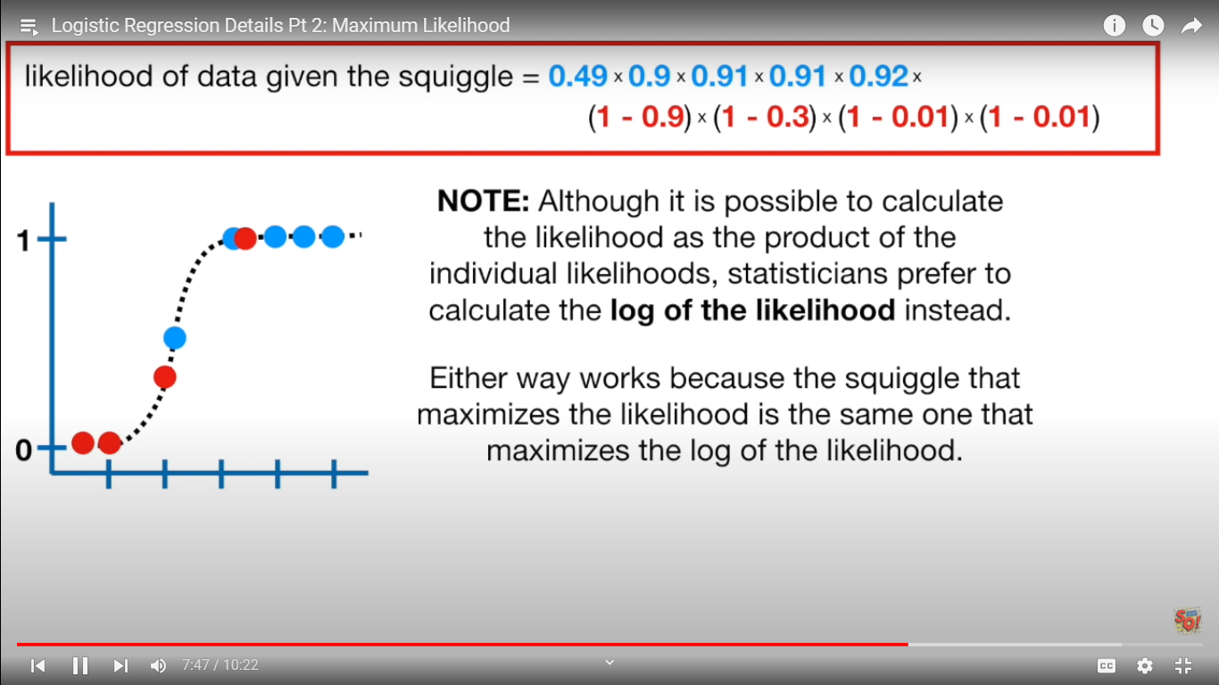

Rotate lie and calculate all again and find log(likelihood) ,with maximum likelihood ie the best fit line

Ie best squiggle

But how do we know this best fit line is useful ? (hint r2 in linear regression)

Not in syllabus

**-------------------------------------------------------------------------------------------------------------------------------------------------------------------------------------------------------------------------------------------------------------------------------------------------------------------------------------------------------------------------**

**REGULARISATION L1 AND L2**

**-------------------------------------------------------------------------------------------------------------------------------------------------------------------------------------------------------------------------------------------------------------------------------------------------------------------------------------------------------------------------**

**MODEL EVALUATION**

**Cross validations**

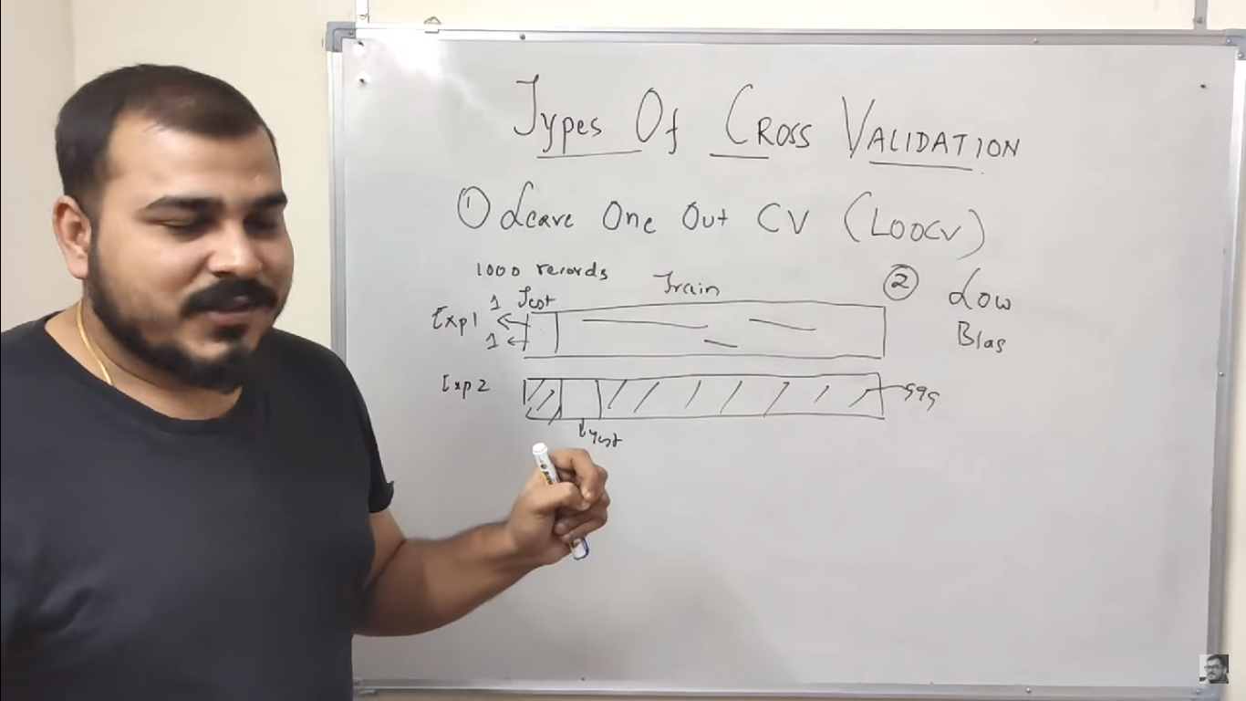

Too many iterations is large data sets

Low bias / high variance , kind of overfitting

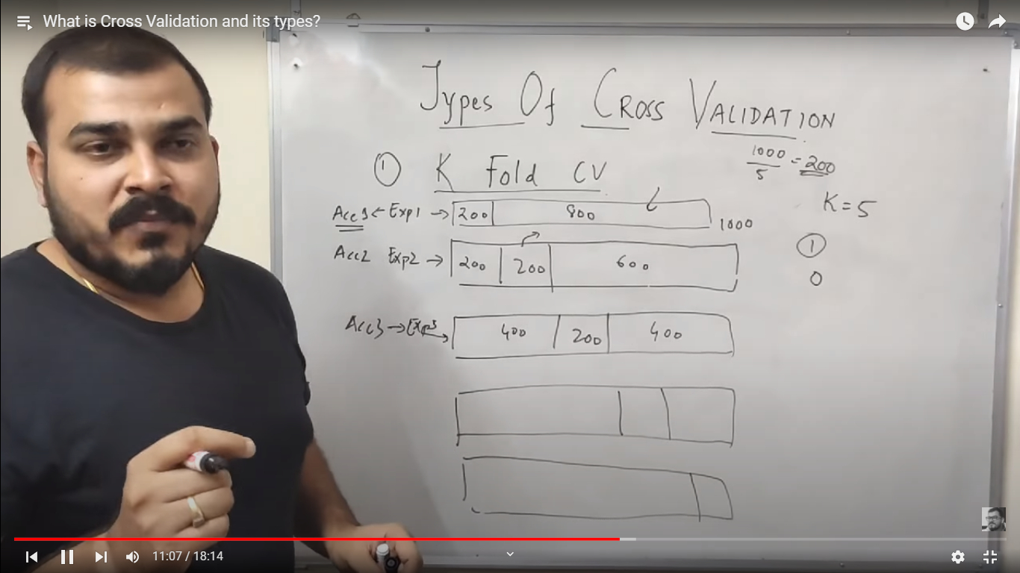

Disadvantage is : 0/1 are not distributed in equal ration smh (no good proporetions of yes and no )

Imbalance data sets

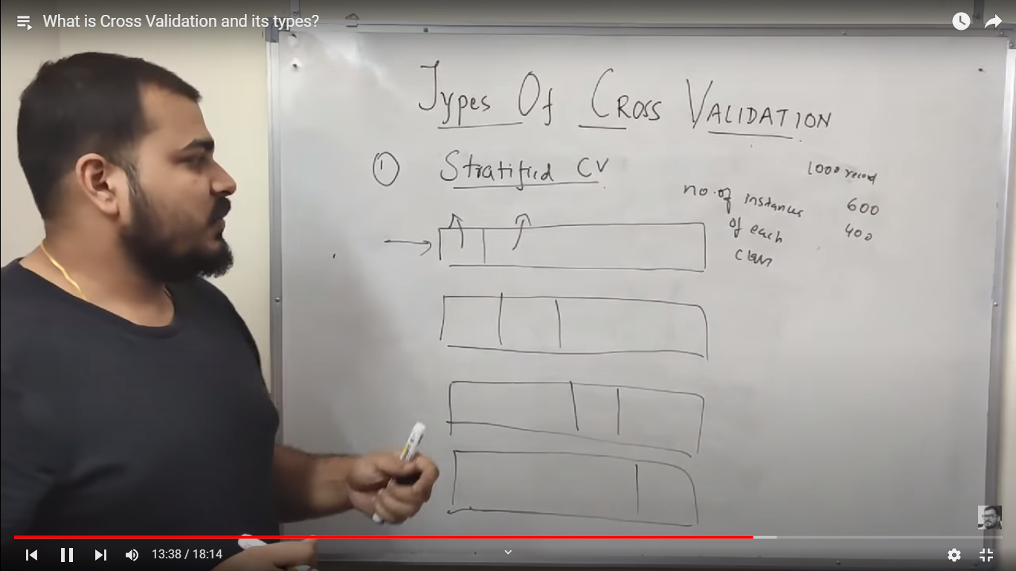

Equal proportions of true and false values.

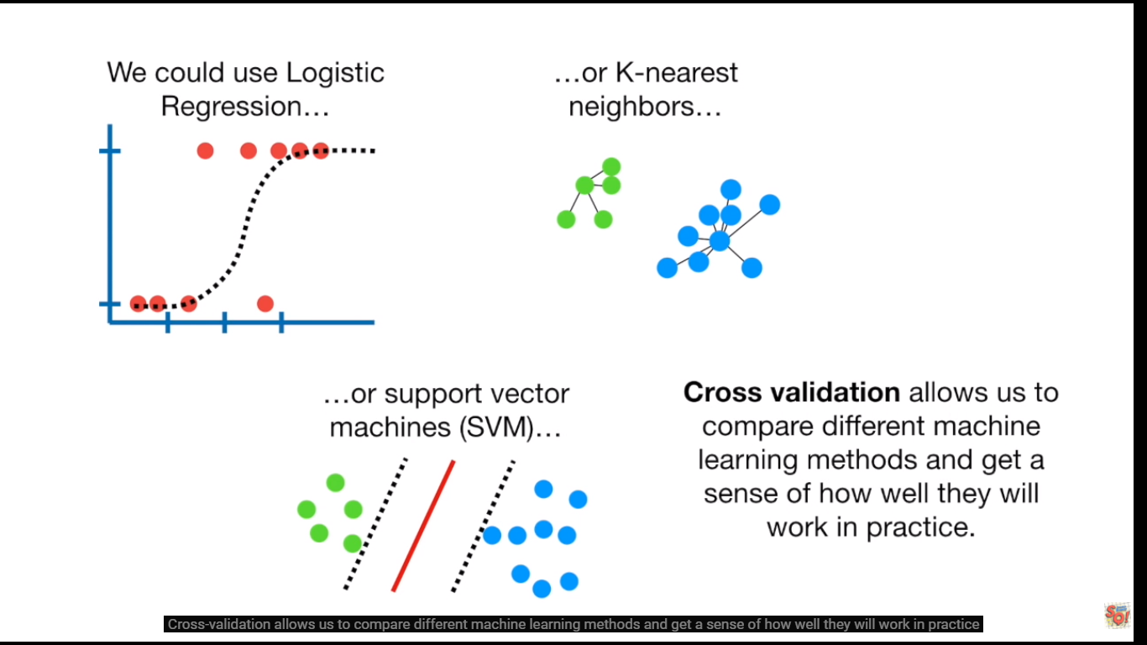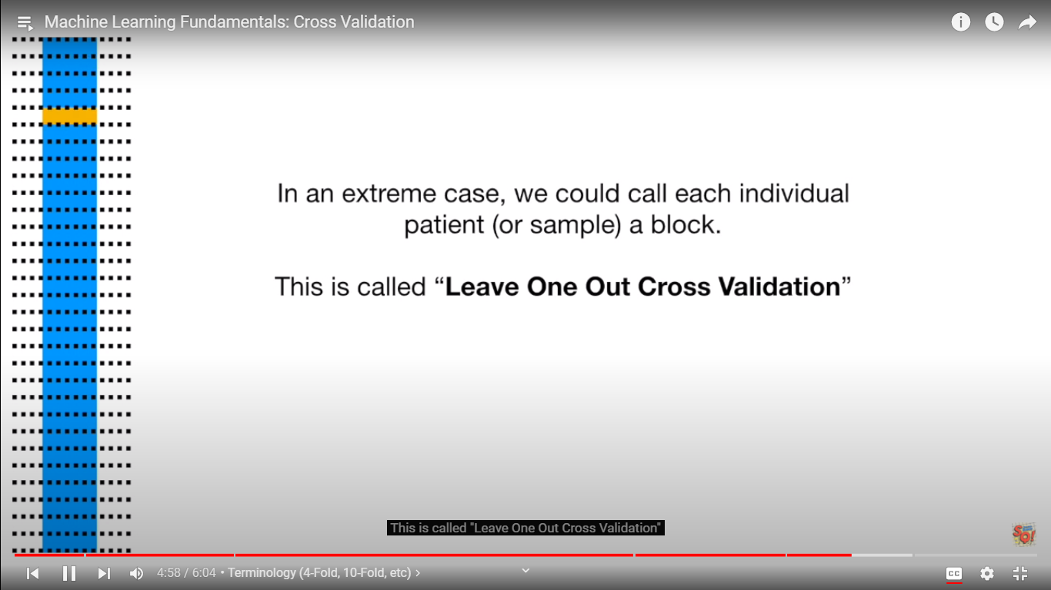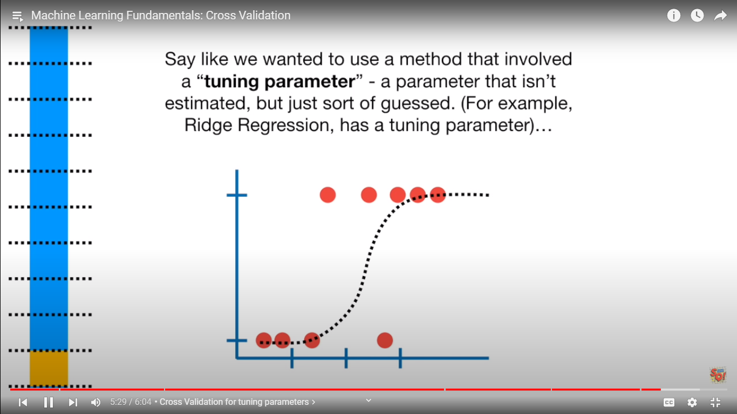

use k folds

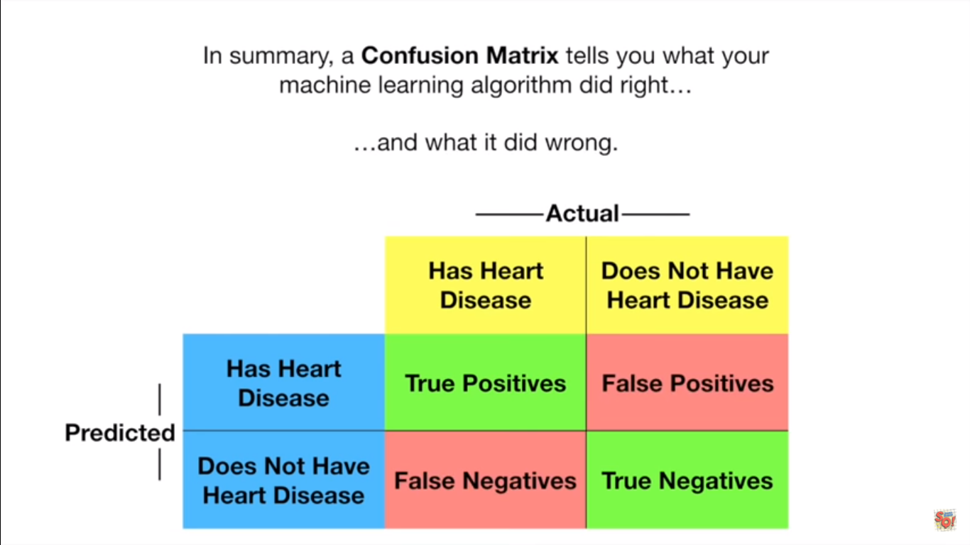

We get confusion matrix for various methods ( like regeression , forest , svm etc) , now which confusion matrix to to chose?

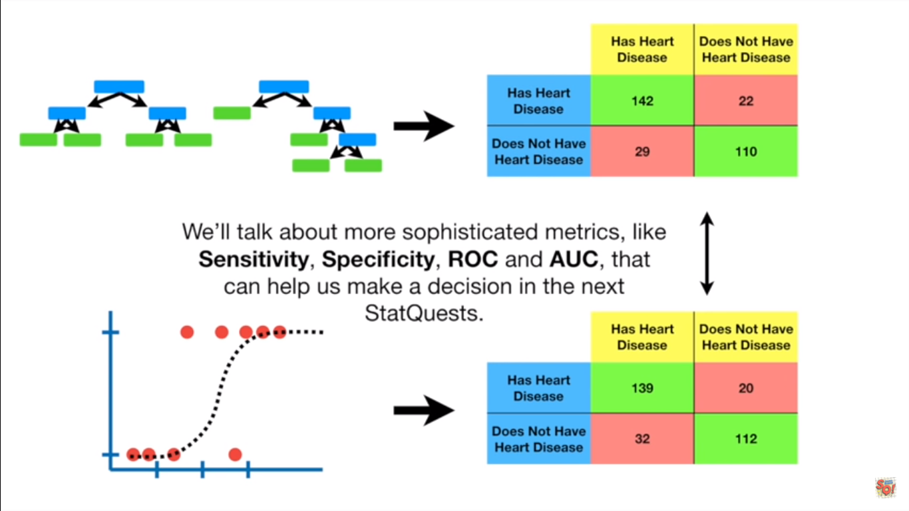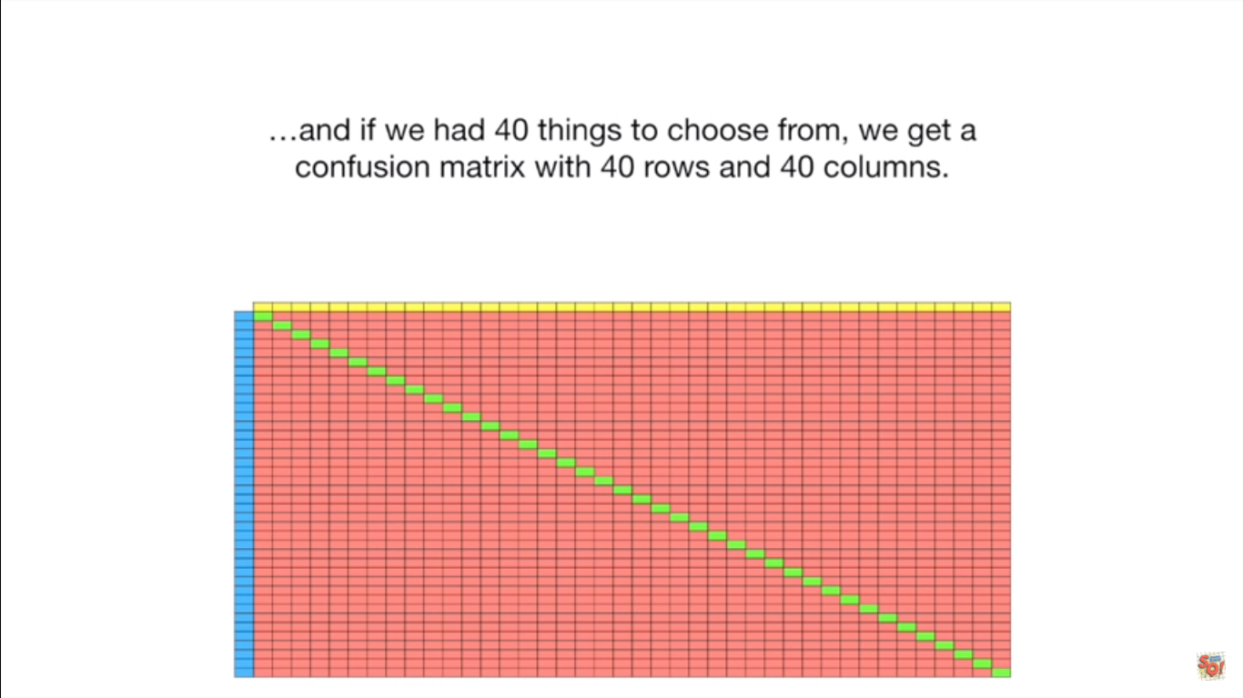

Sensitivity and specificity

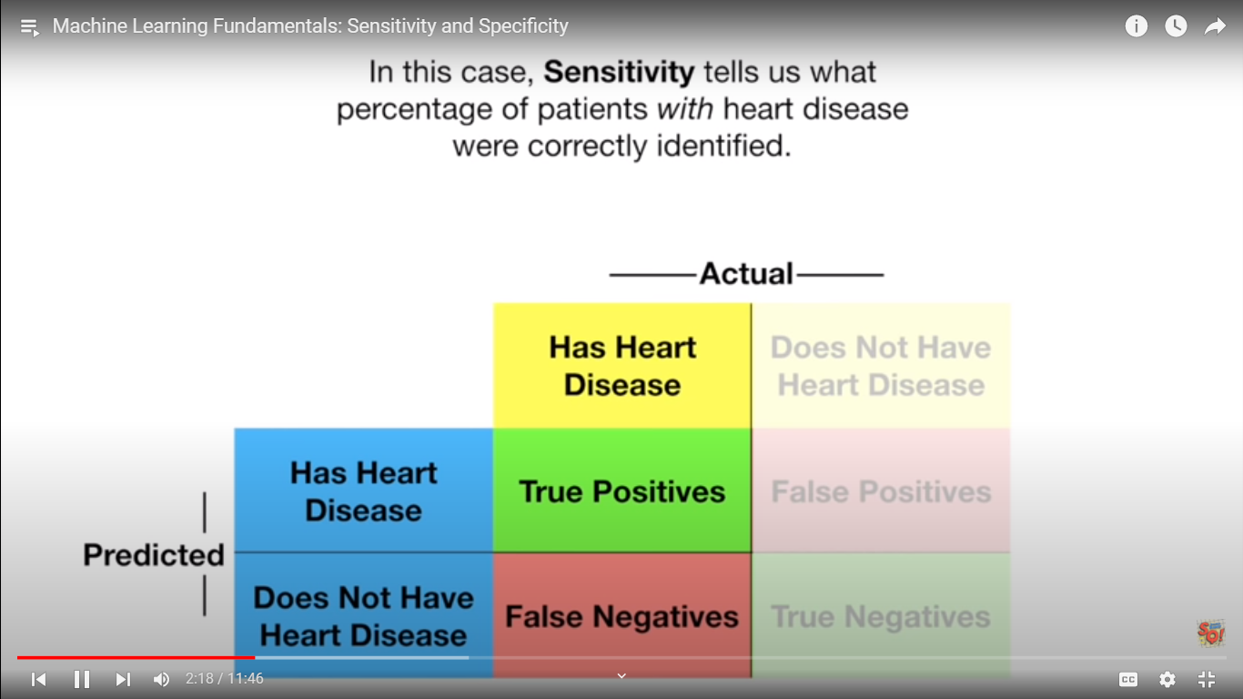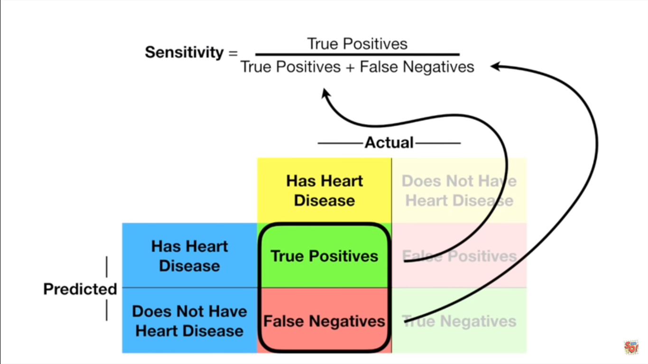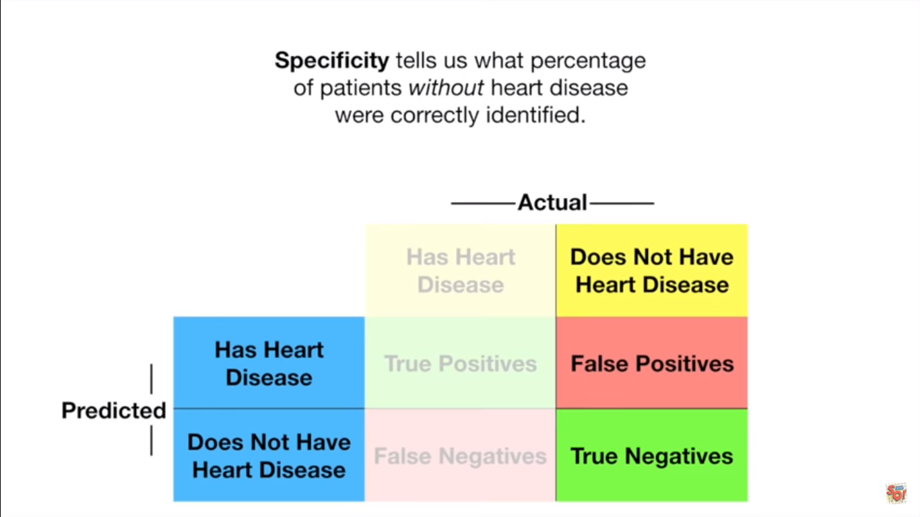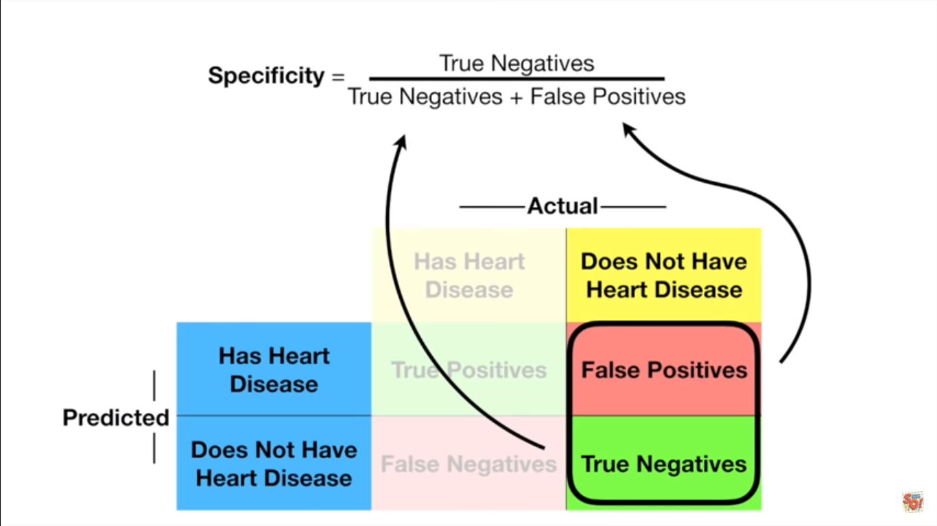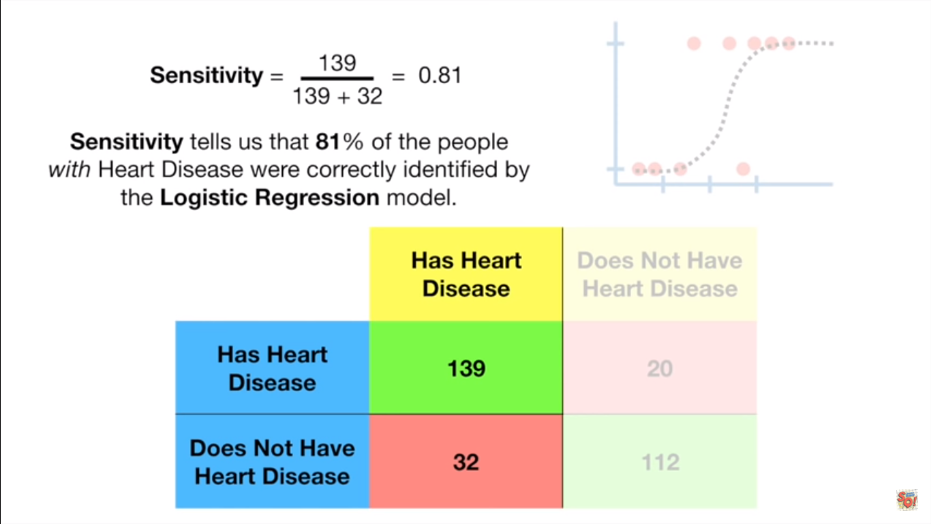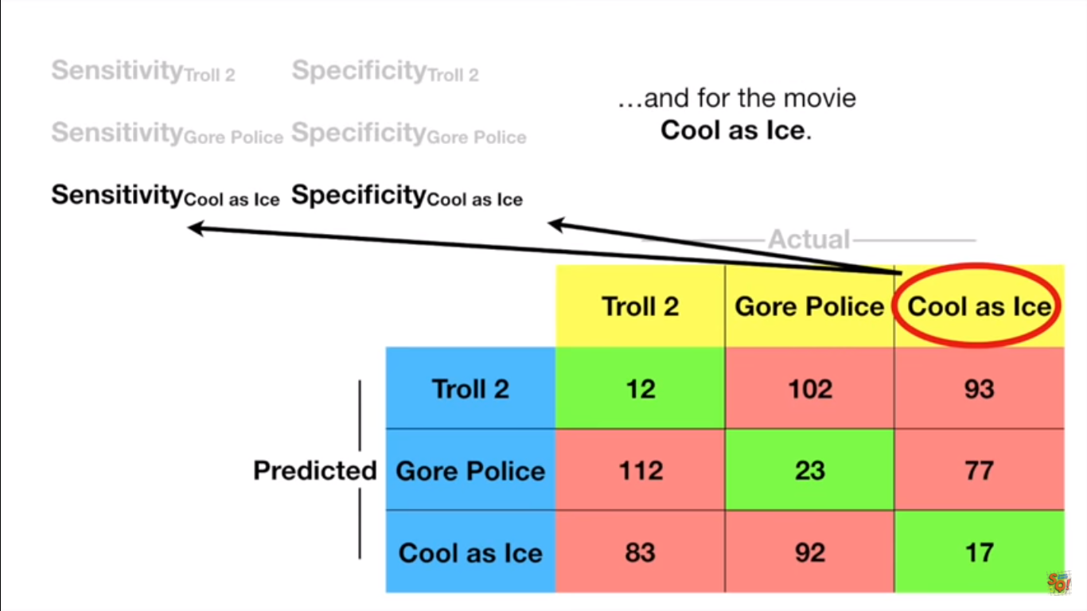

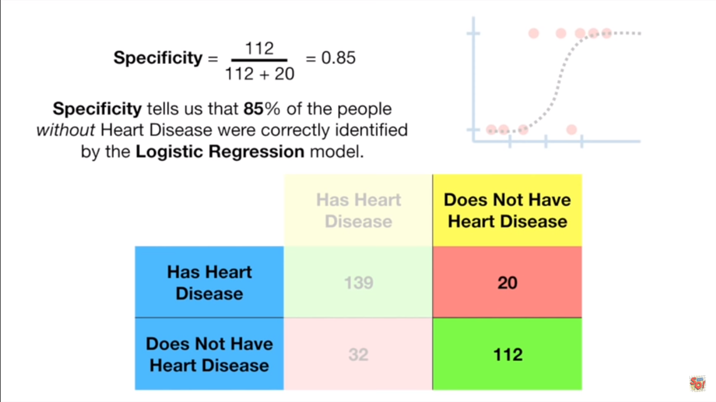

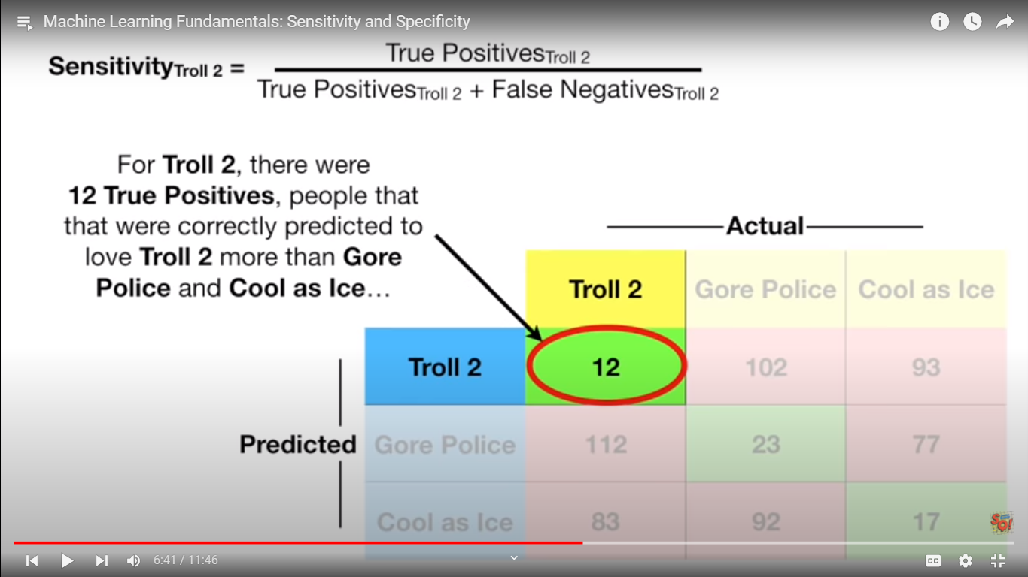

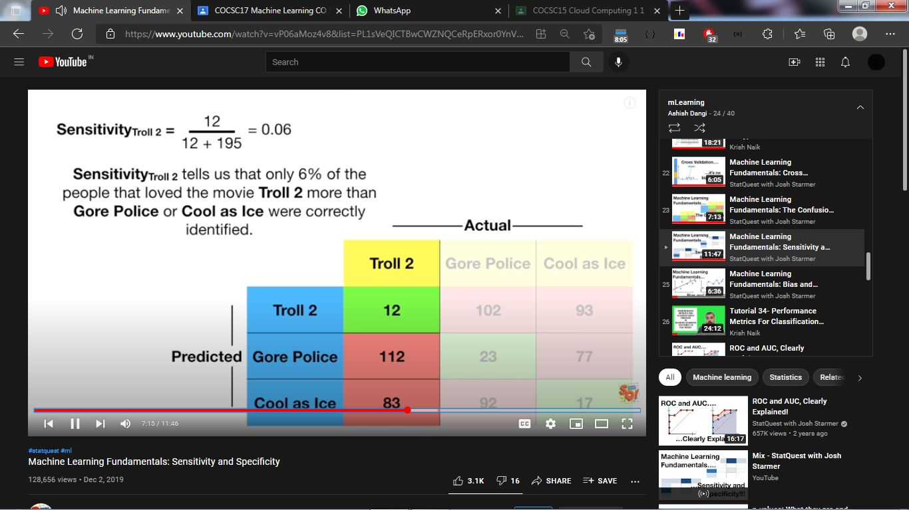

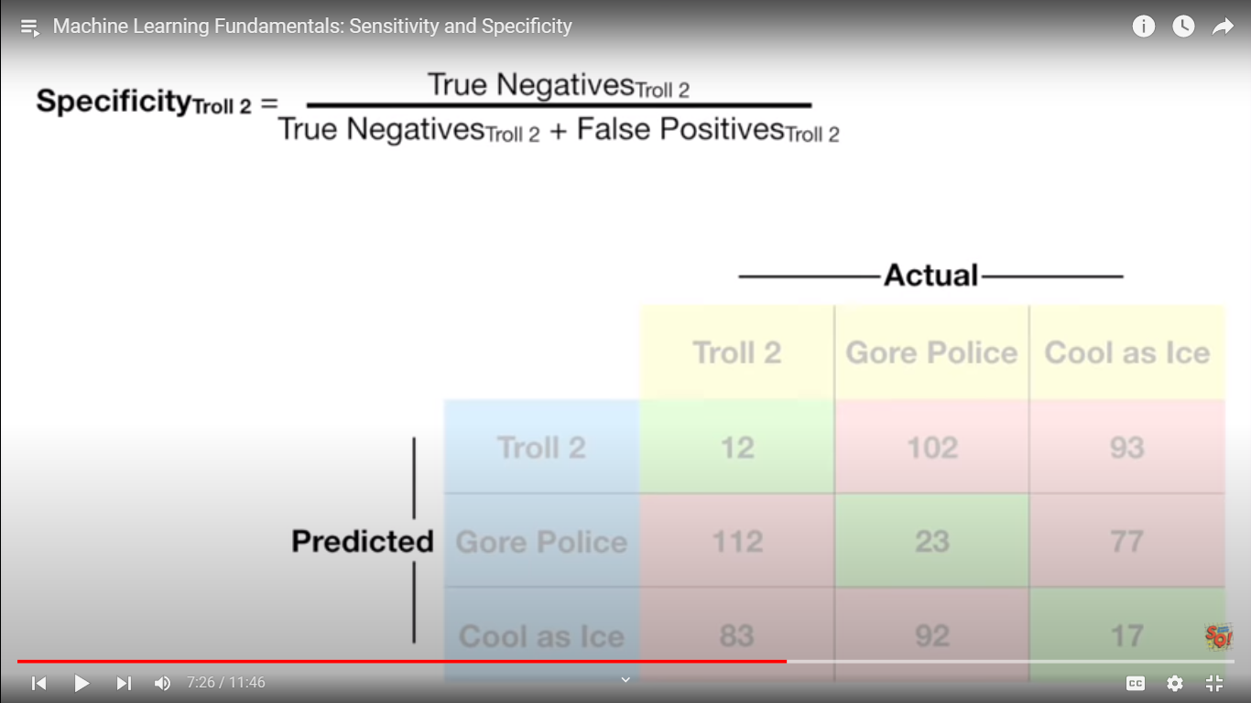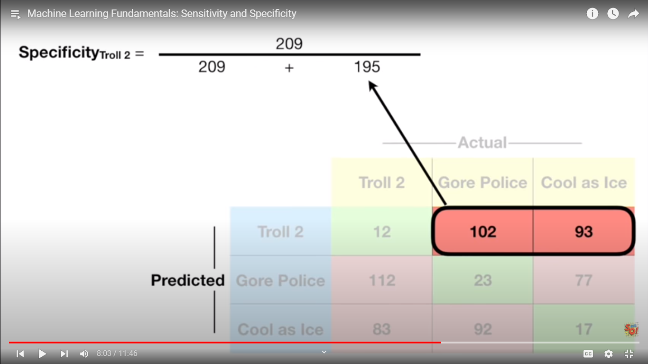

In easy words

**Sensitivity : no of things in favour and identified correctly / no of things in favour and identified correctly + no of things in favour and identified wrong**

**: no of things in favour and identified correctly / total no of those things in favour in actual**

**Troll2** = 12 / 12+ 112 + 83

**Specificity : no of things in against and identified correctly / no of things in against and identified correctly + no of things in against and identified wrong**

**: no of things in against and identified correctly / total no of those things in against in actual**

**Troll 2=** 23+77+92+17 / 23 +77+92+17 + 102+93

Bias :

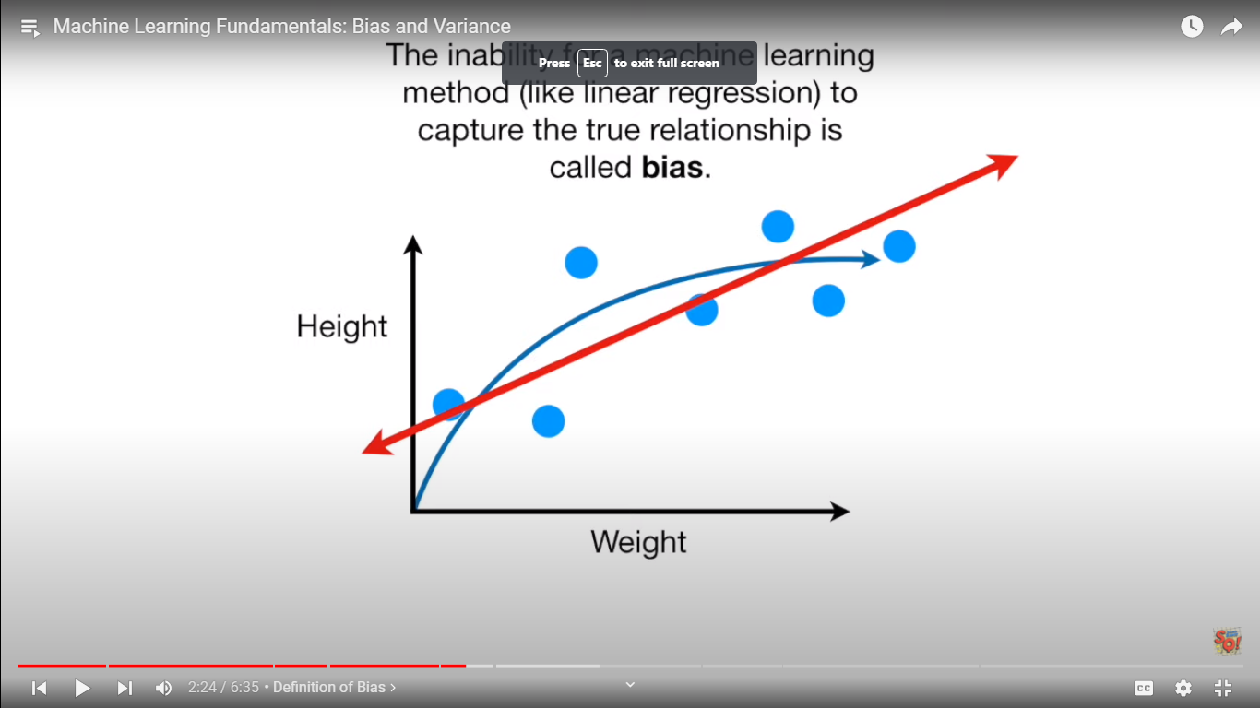

Underfitting has high bias .

Over fitting has low bias.

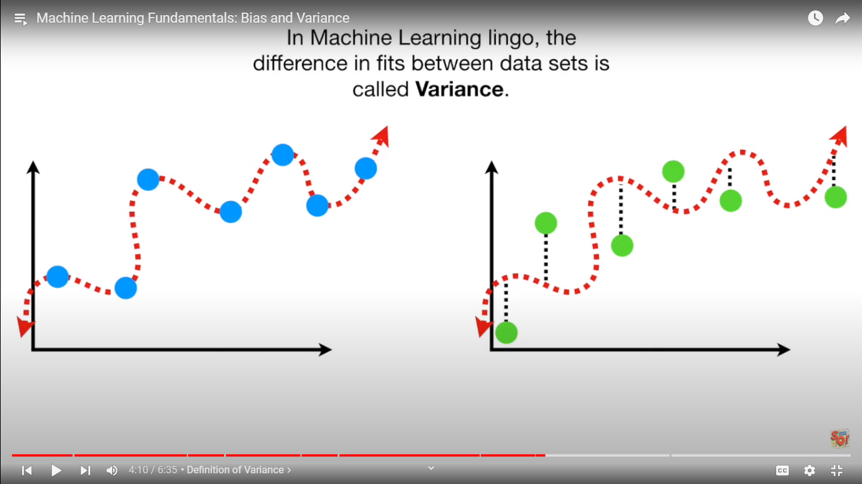

Underfitting has low variance .

Over fitting has high variance.

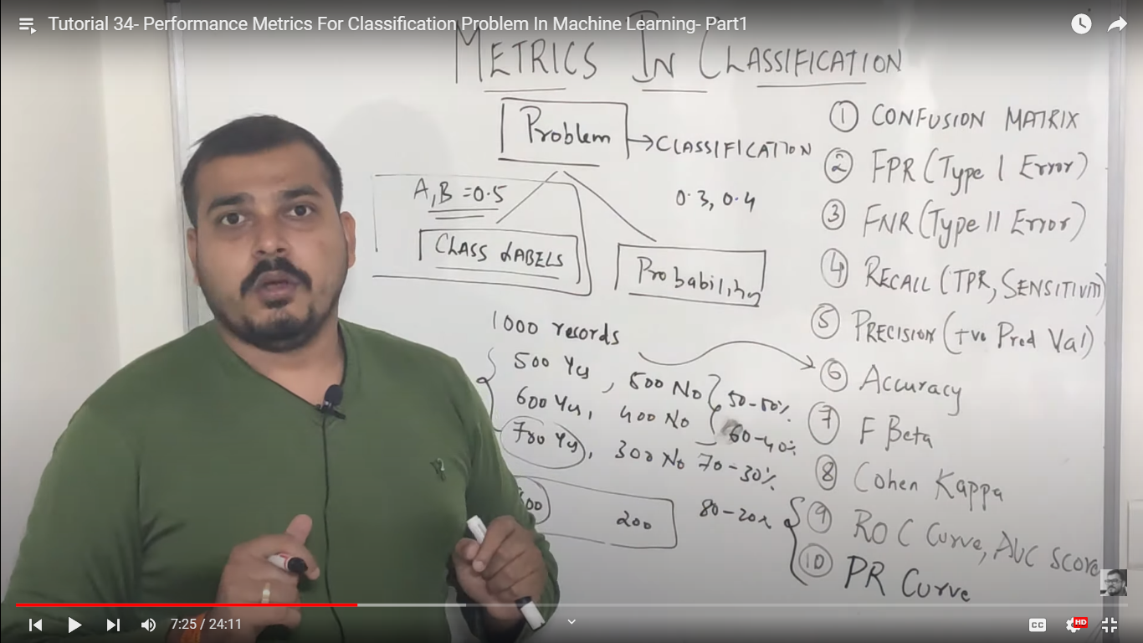

Class labels : thoshold values = 0.5

Balanced data sets -> accuracy

Unbalanced datasets -> recall, precision, f beta

Probabilities: first find threshold values ROC , AUC , PR curves

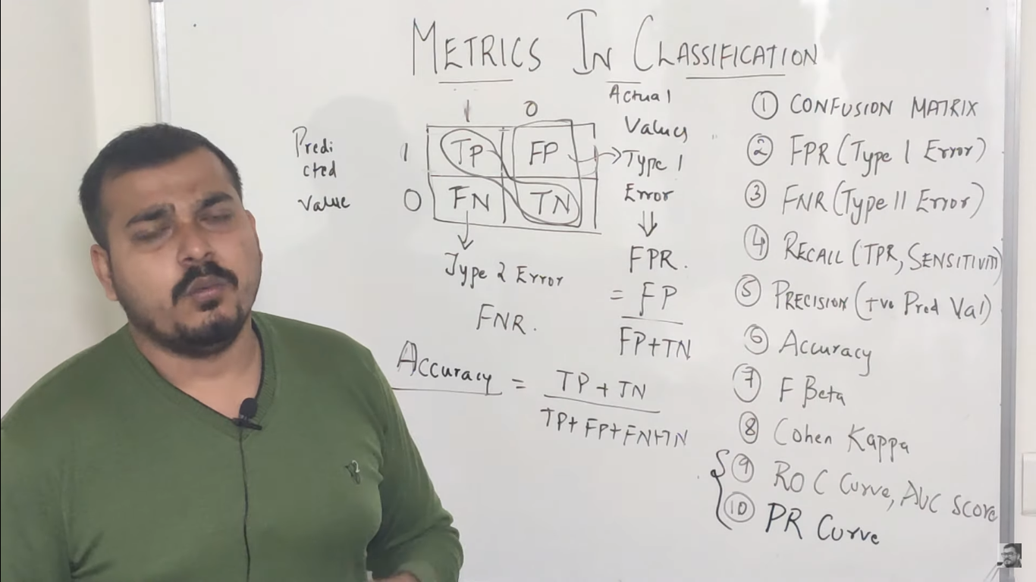

Try to reduce type 1 and type 2 errors

For unbalanced data sets :

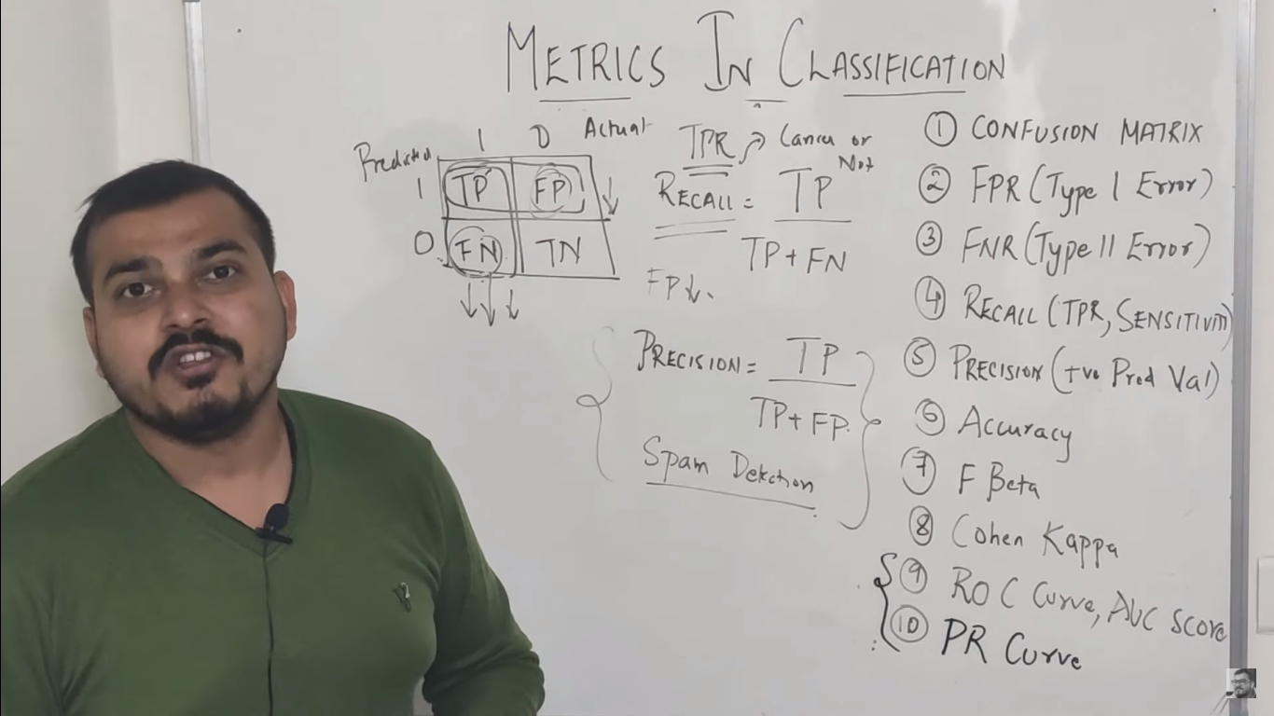 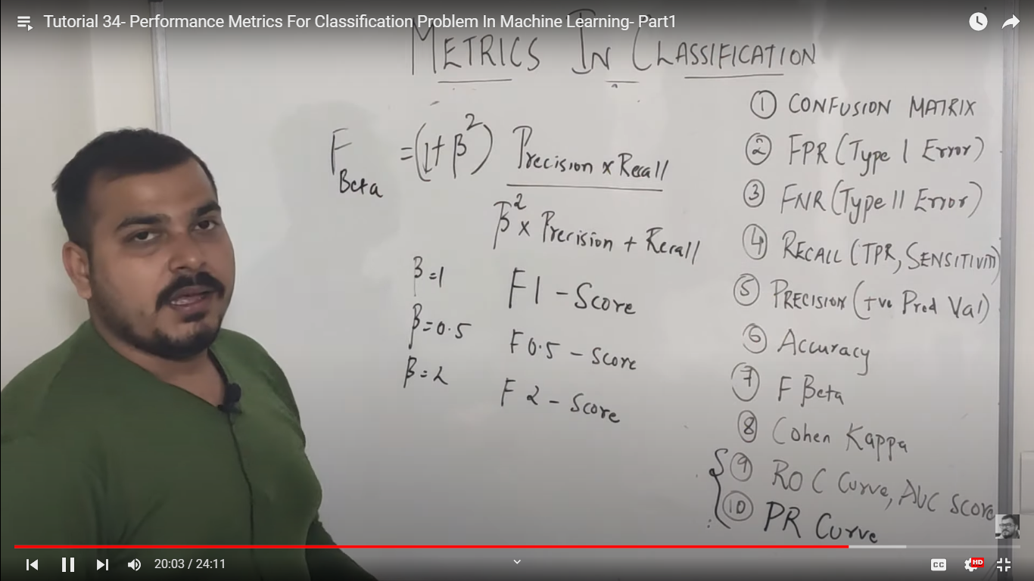

Impact

B = 1 -> FP = FN

B = 0.5 -> FP>FN

B = 1.5 -> FP<FN

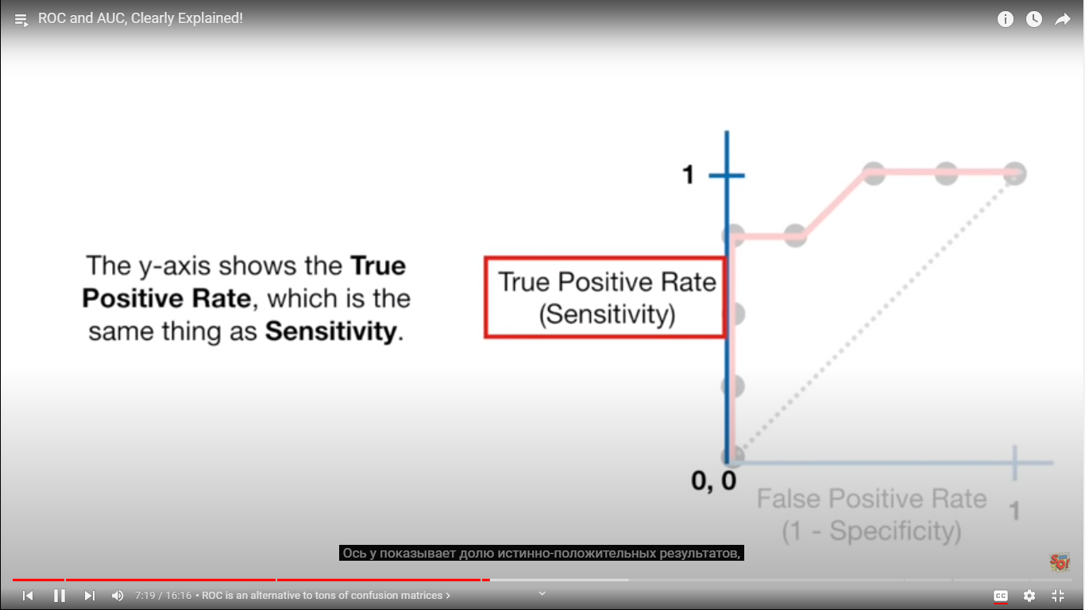

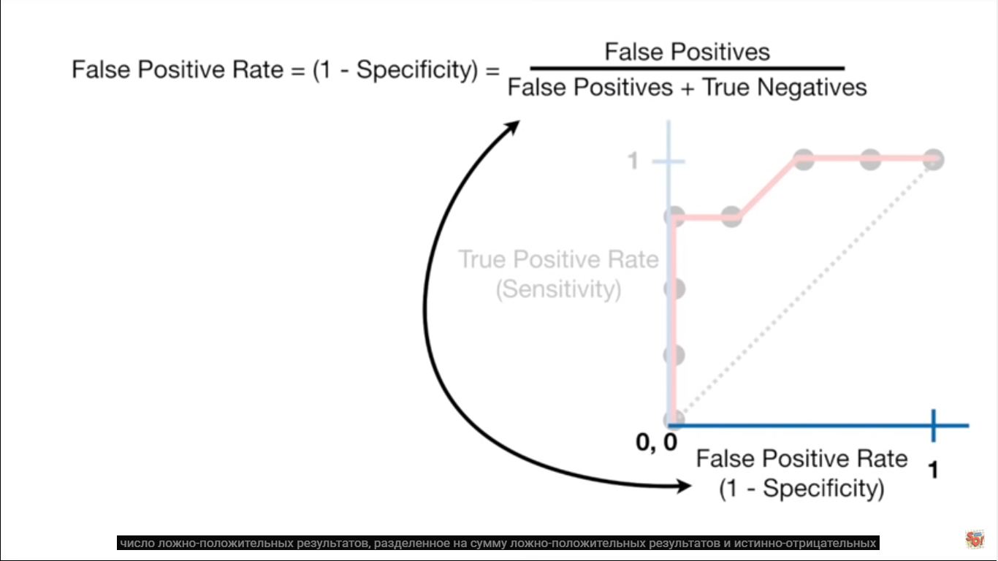 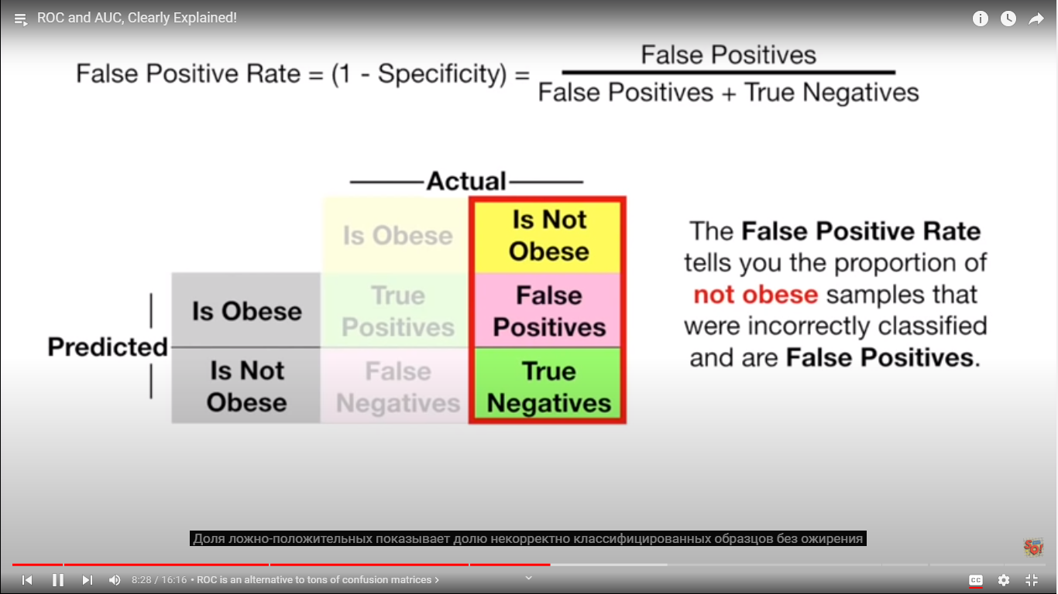 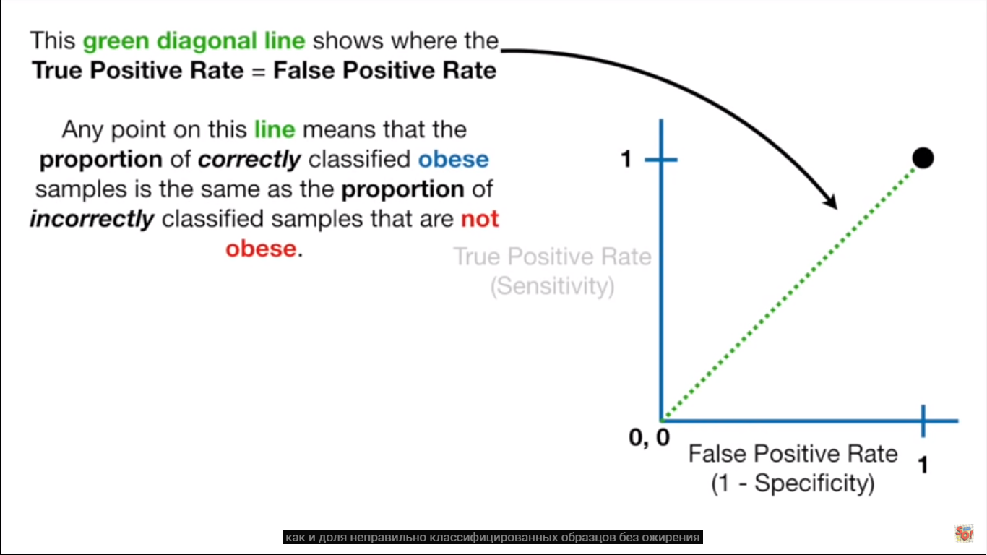 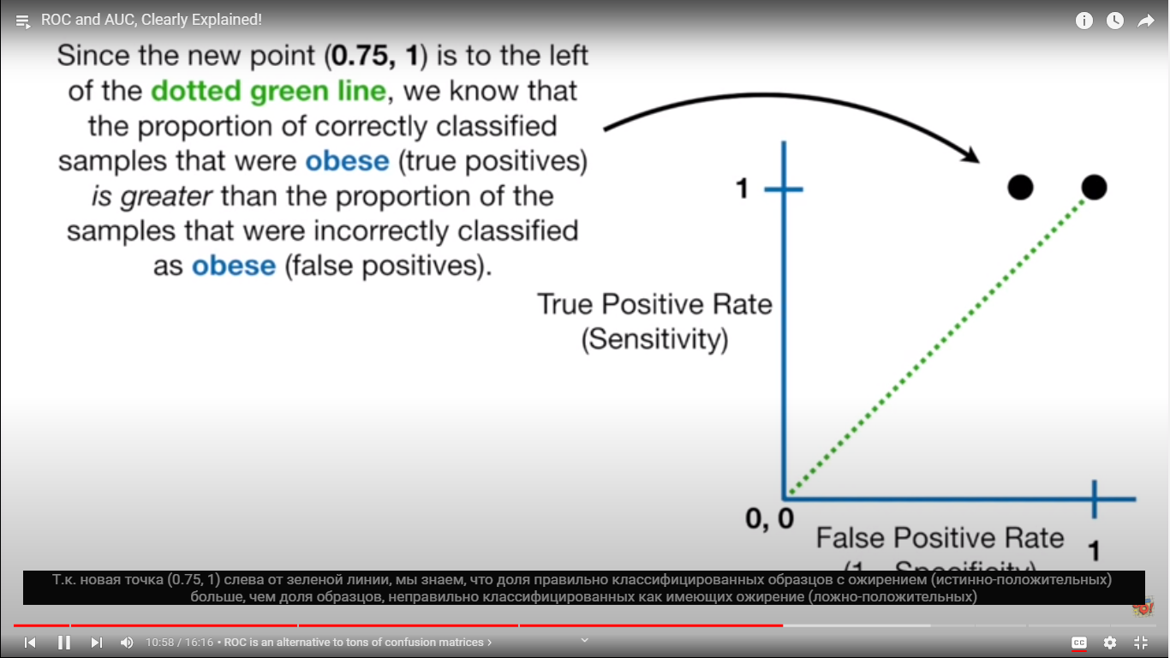 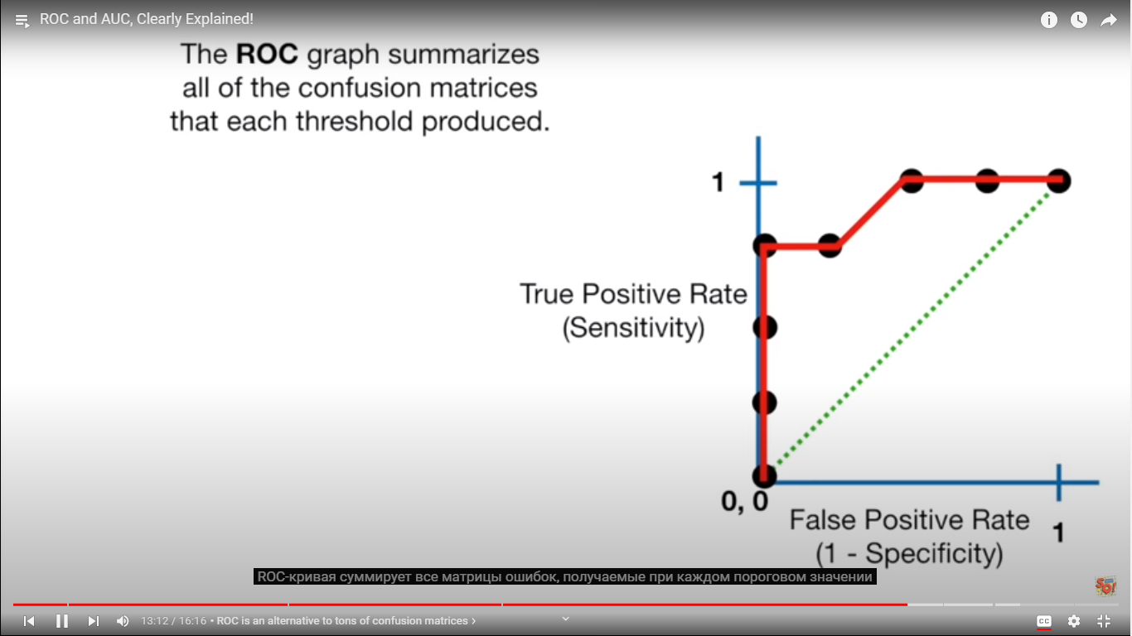 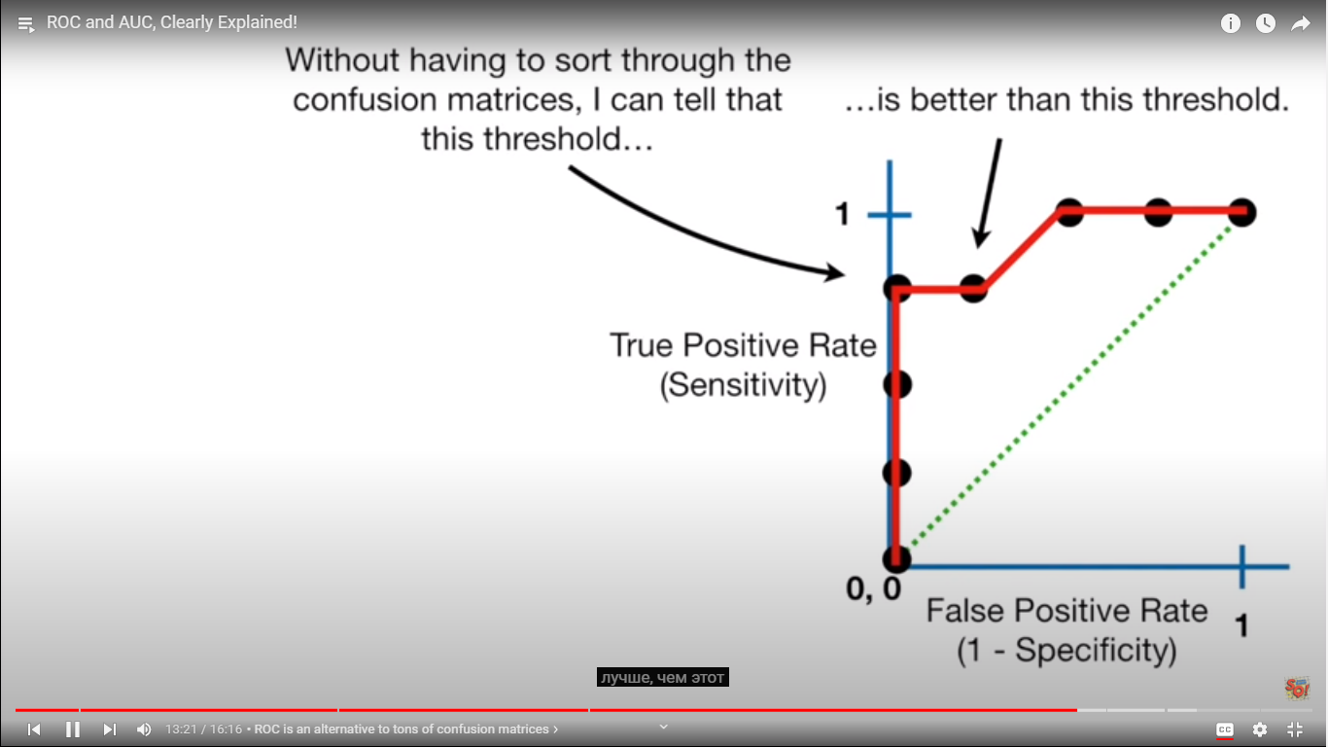 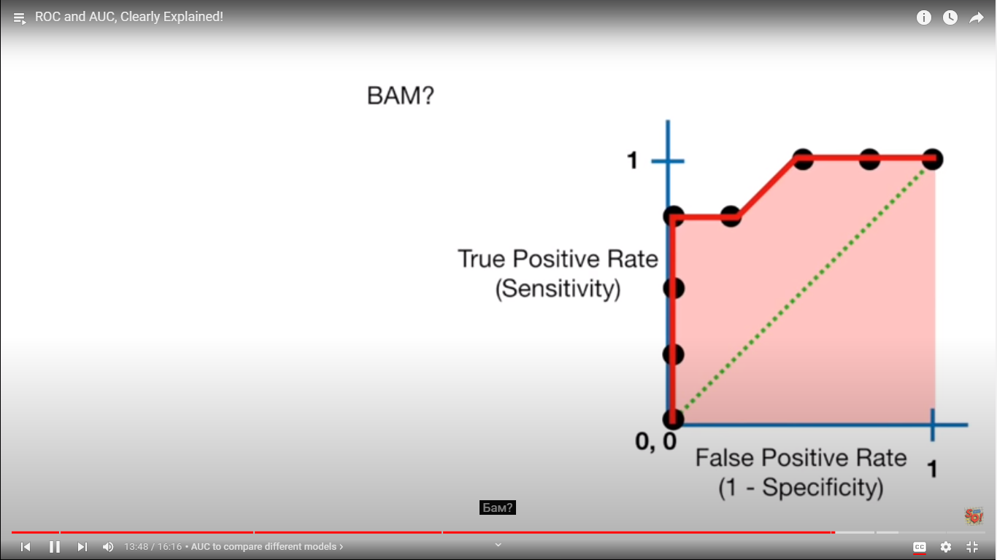 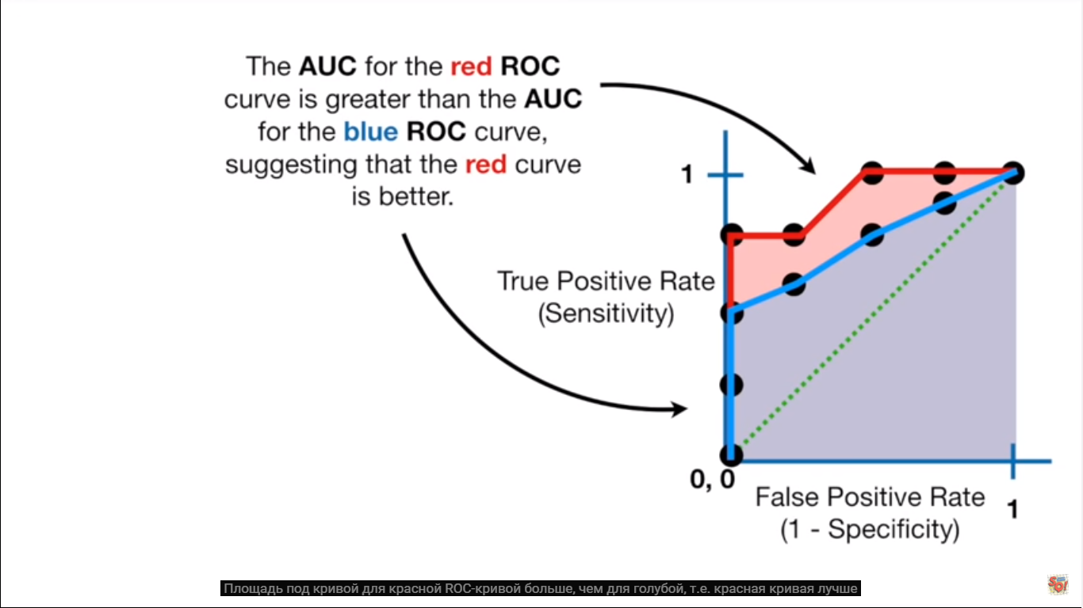 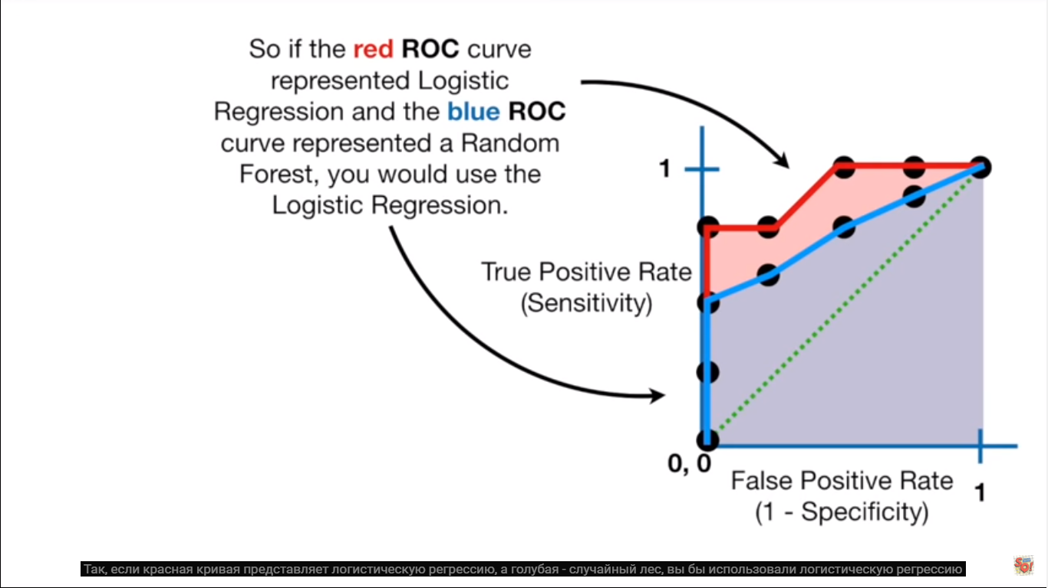 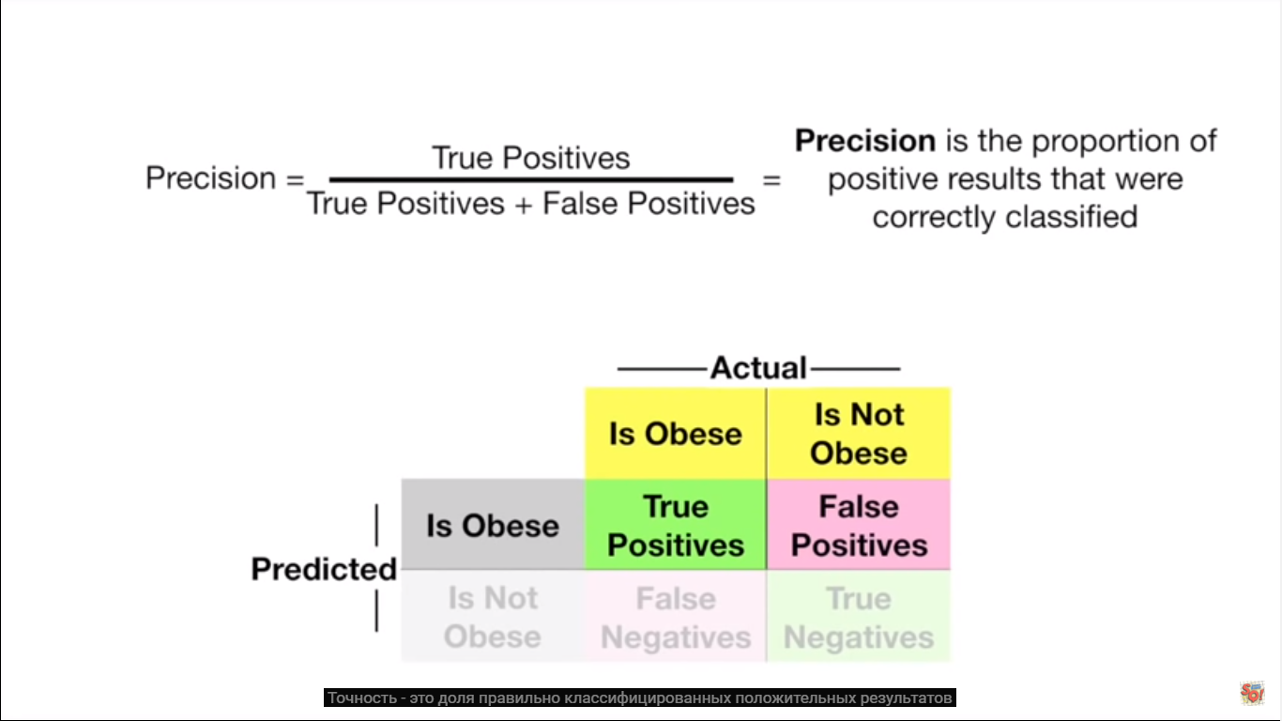

**-------------------------------------------------------------------------------------------------------------------------------------------------------------------------------------------------------------------------------------------------------------------------------------------------------------------------------------------------------------------------**

**DECISION TREES**

Decision tree is iterative leaning model. A Decision tree is a flowchart like tree structure, where each internal node denotes a test on an attribute, each branch represents an outcome of the test, and each leaf node (terminal node) holds a class label.

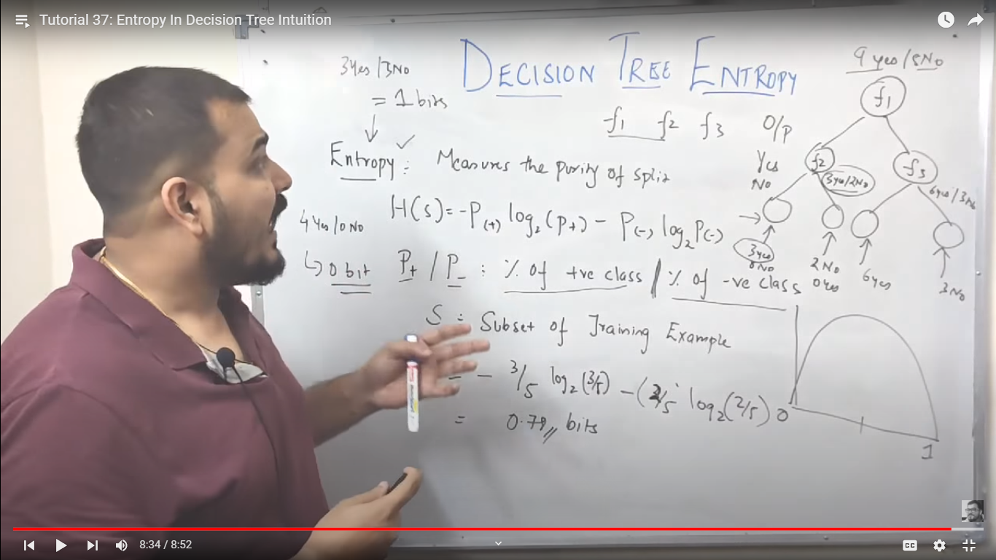 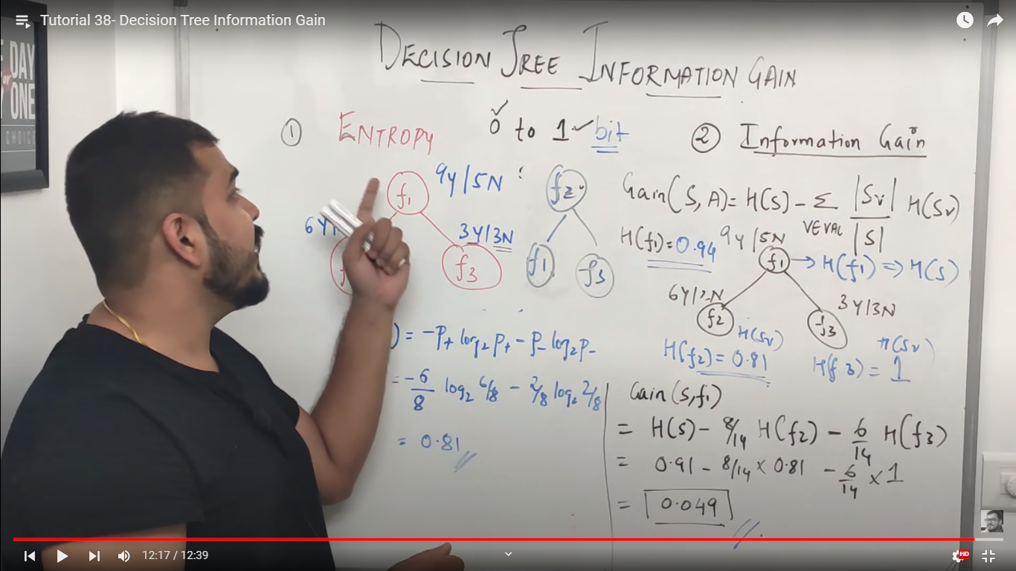

Higher the IG that tree would be taken in account .

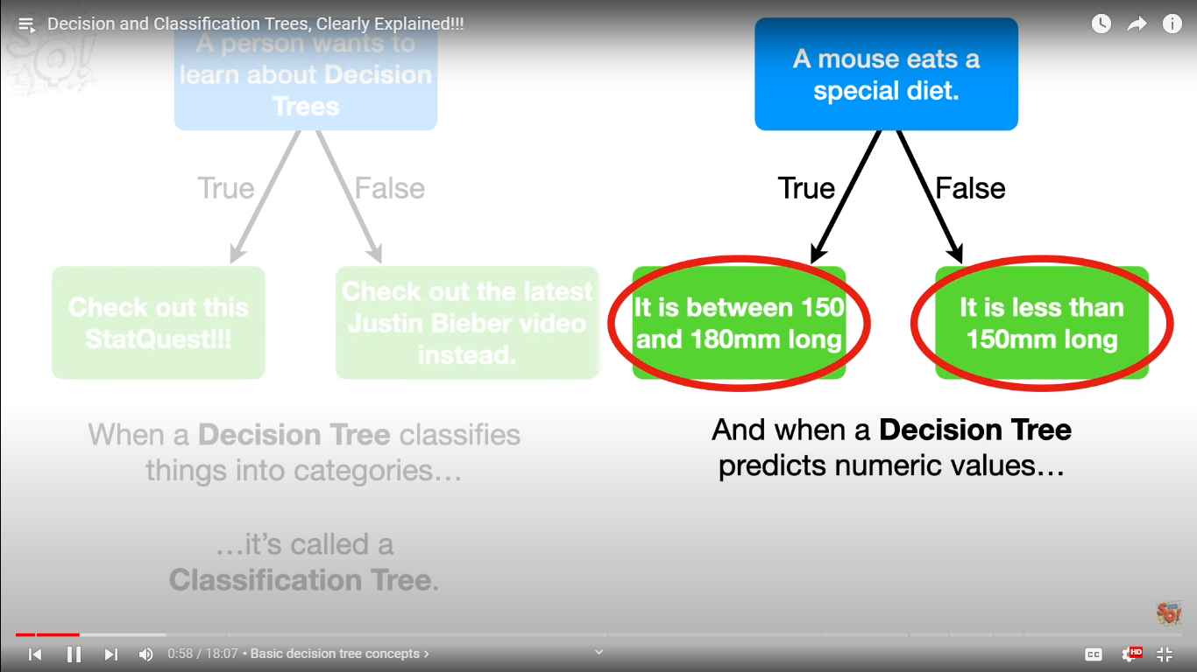 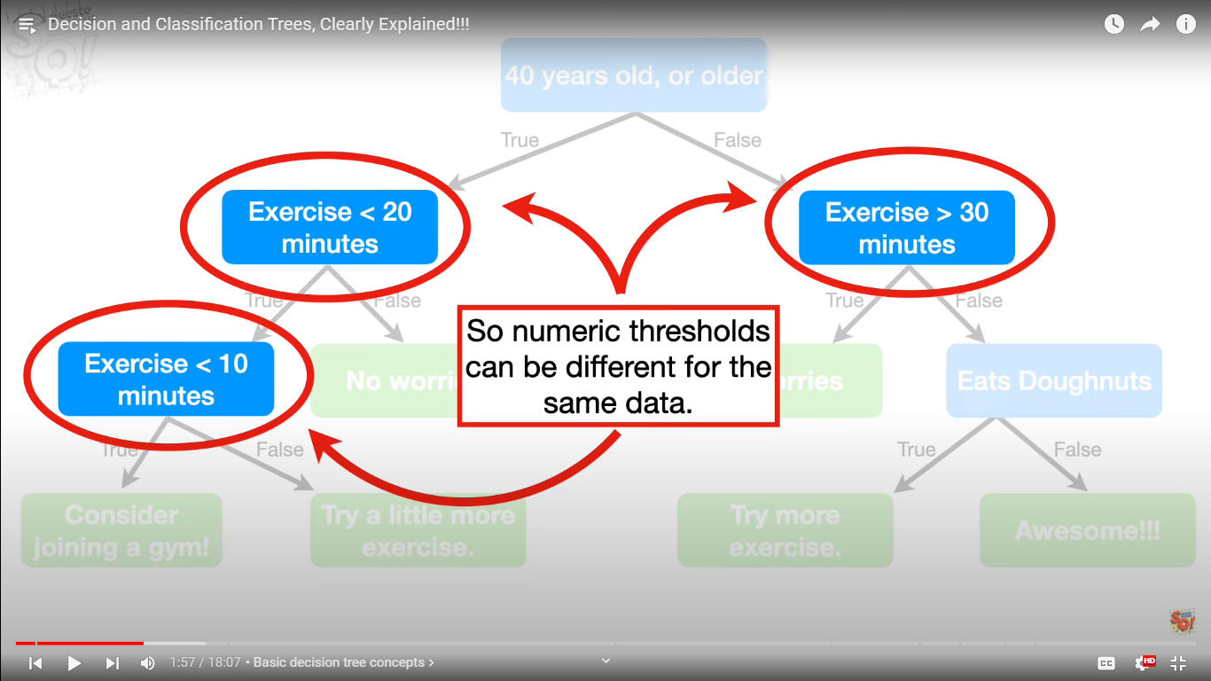 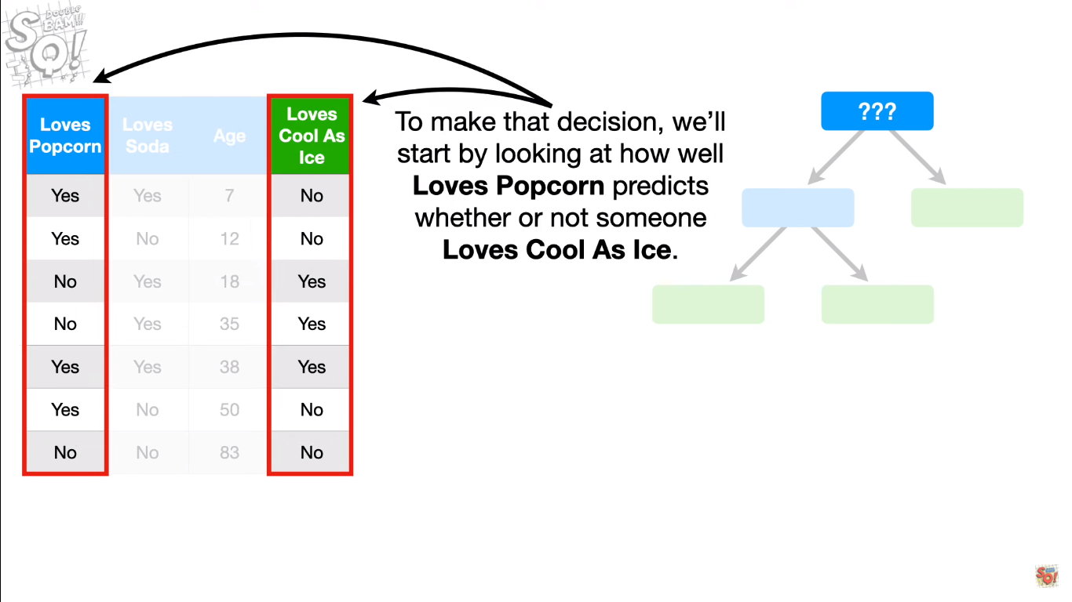 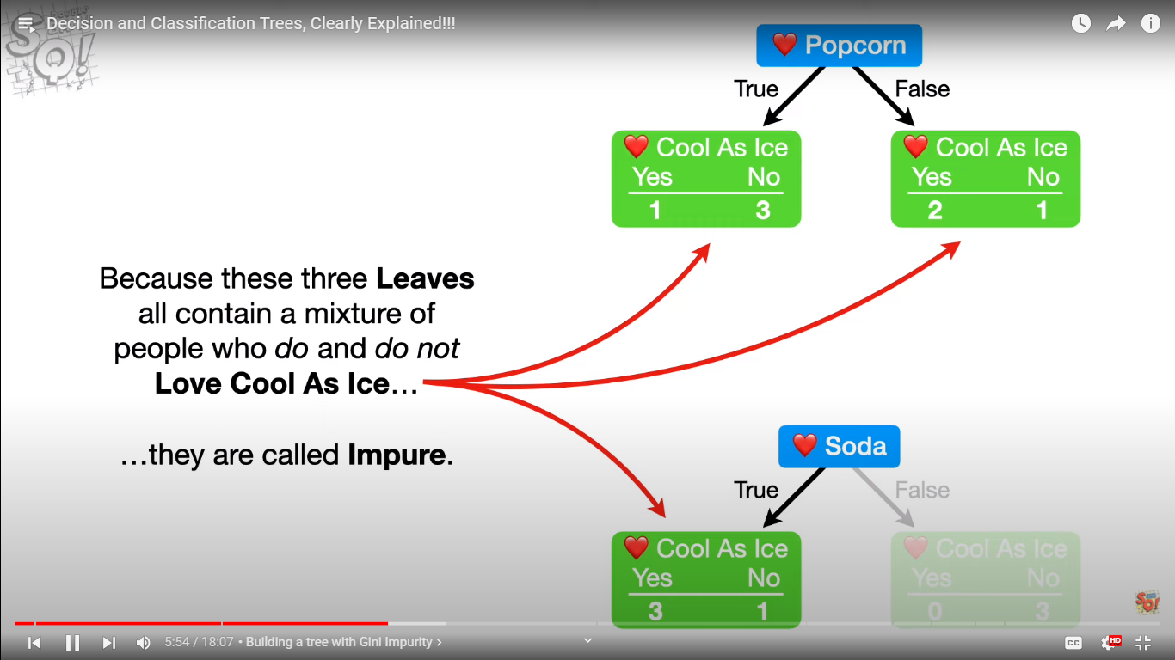 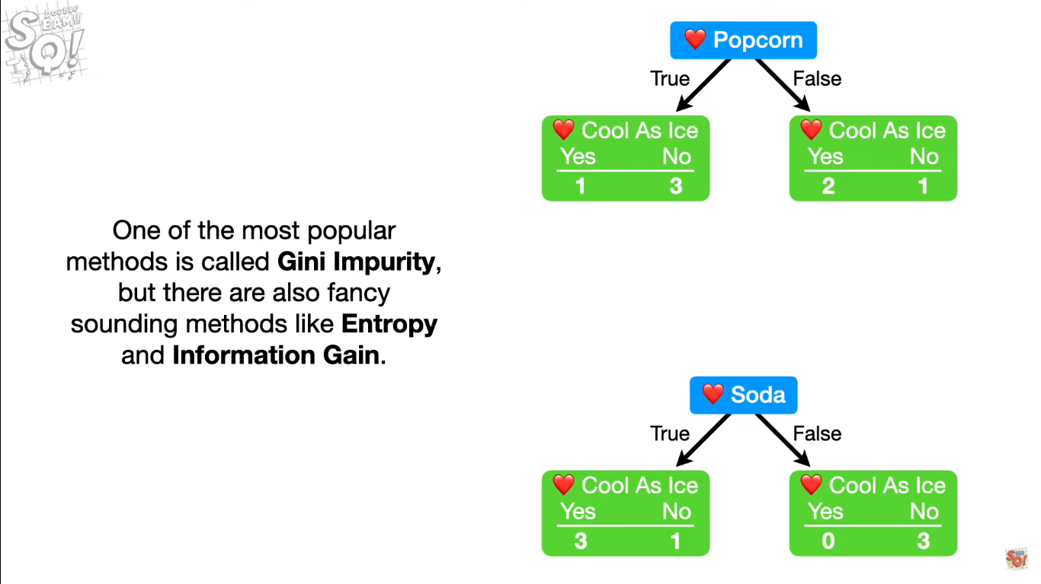

Gini impurities

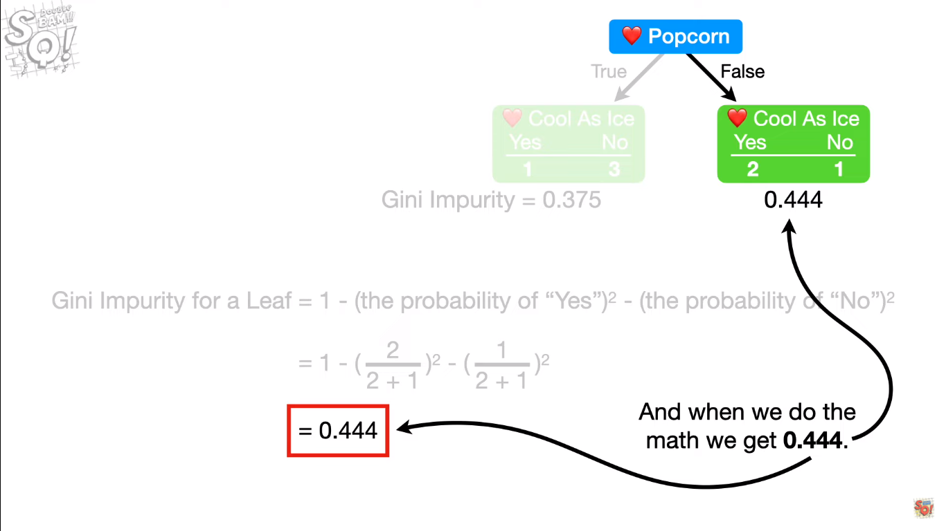 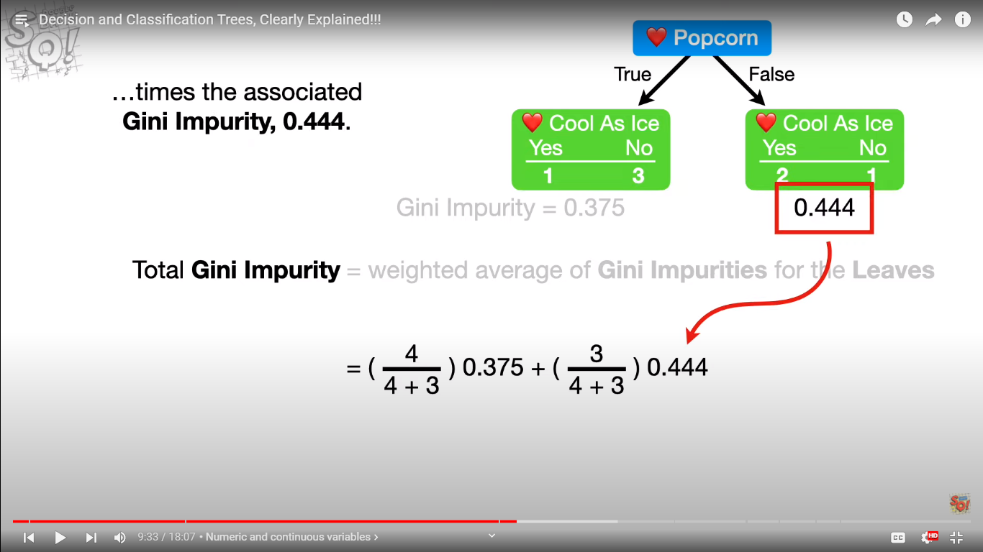

Gini impurtiy for numeric data

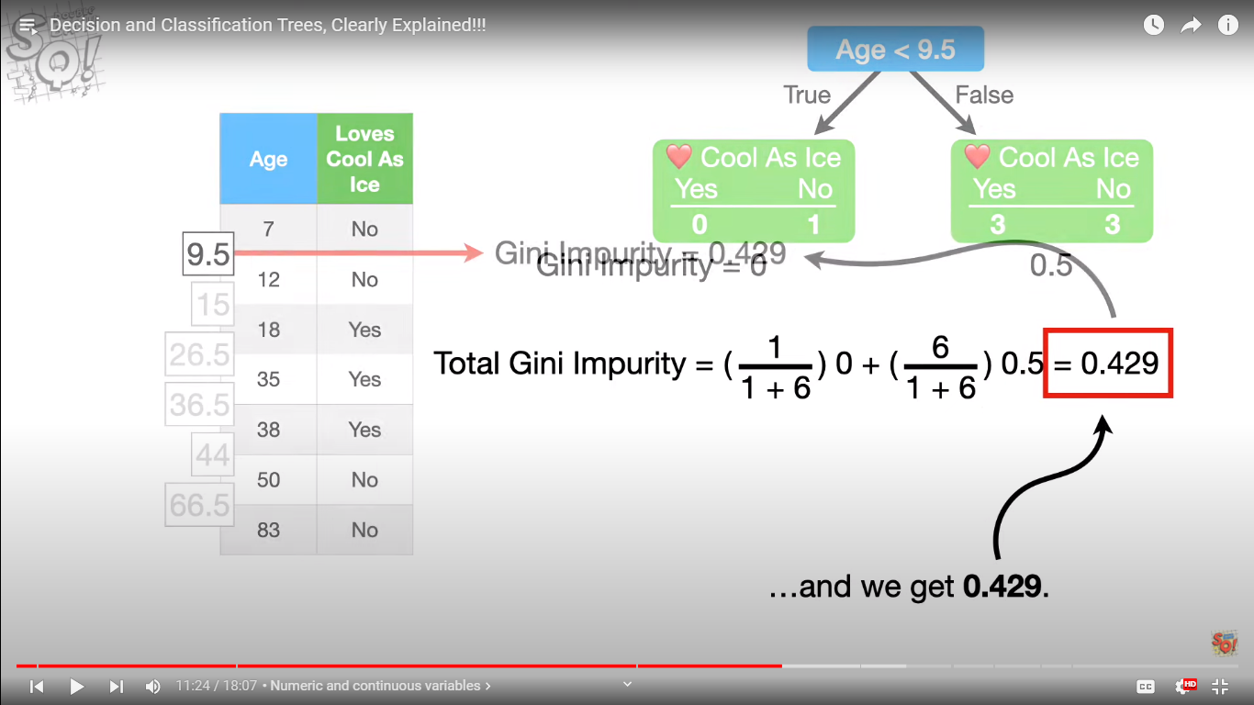

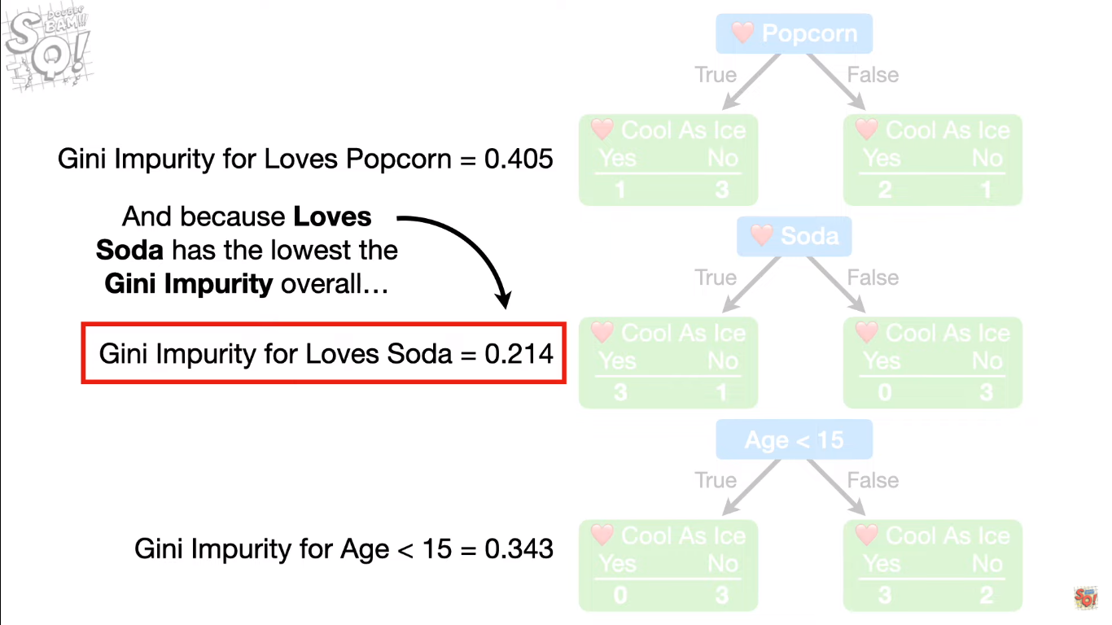 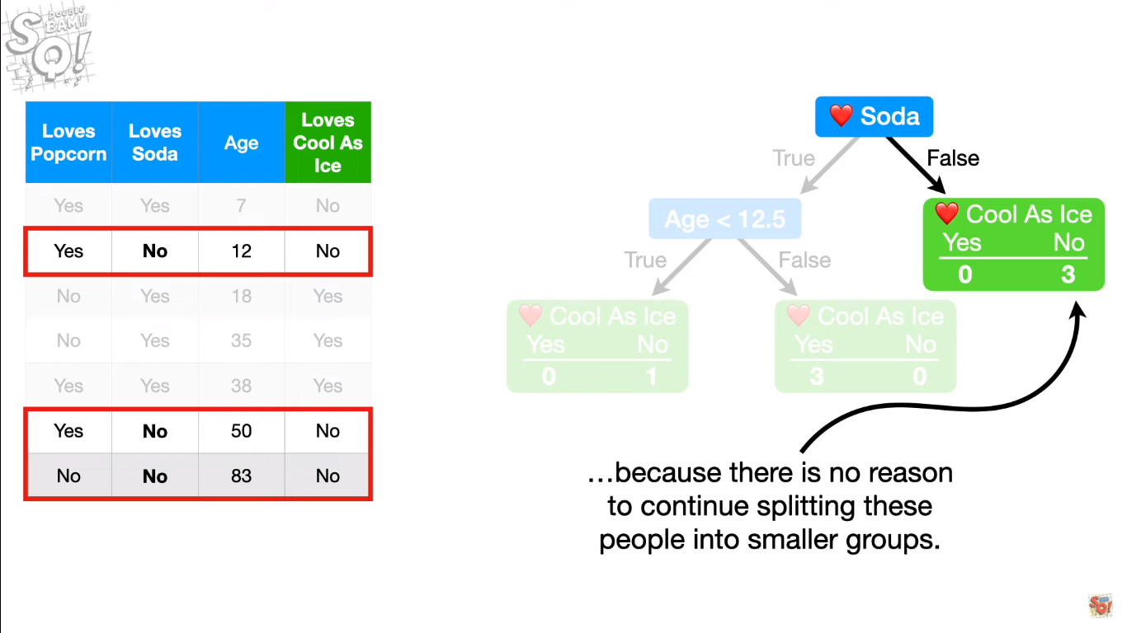 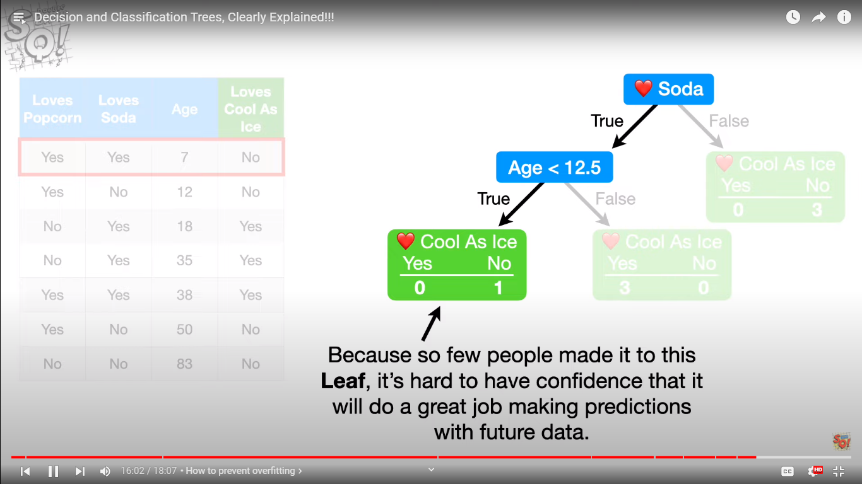

**We might have overfit the data , method to deal with it (one of the )) is pruning !**

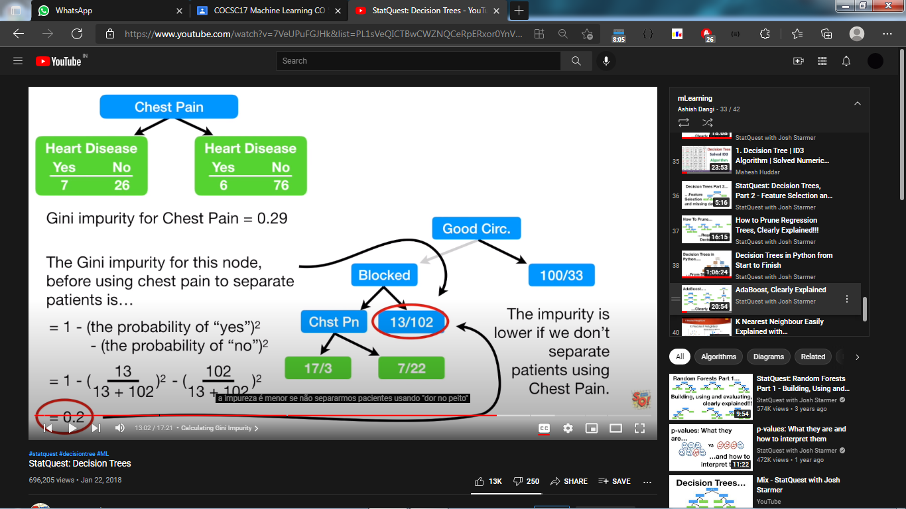

**So we make it the leaf node**

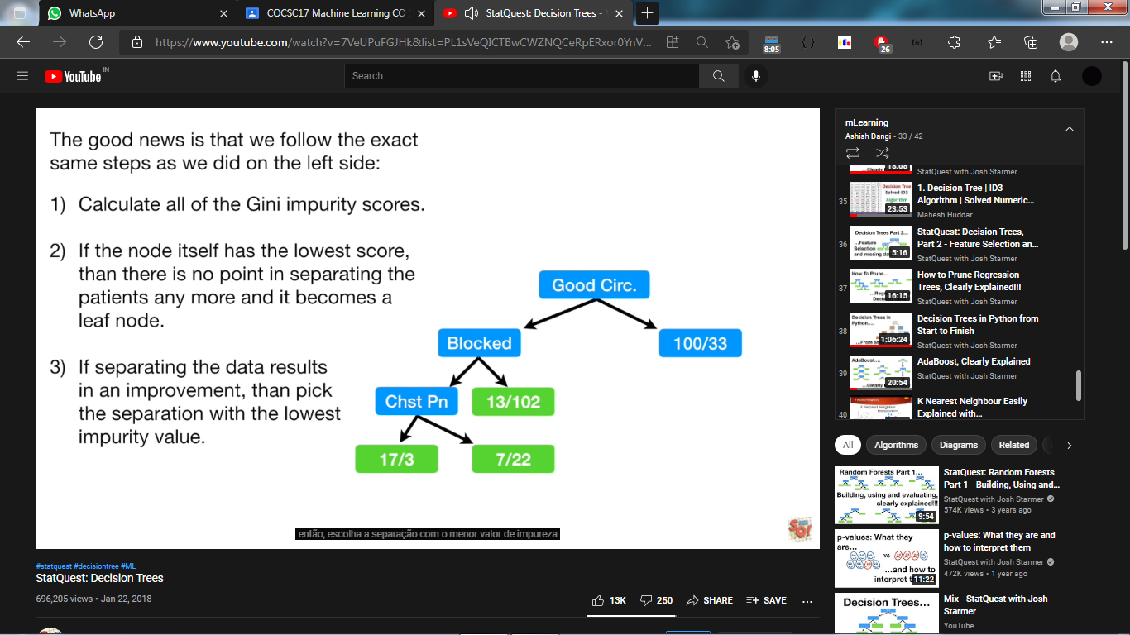

**Tree using IDE3 algorithm :**

Calculate info gain of each attribute and decide which one will become node(the one with higher IG)

IG is calculated by that formula = entropy of set – sigma (weighted sum of entropy of indivisual )

smh!

Hard work and concentration is needed , not my type!! Uff!!

**Tree pruning**

Method 1 -> sample size

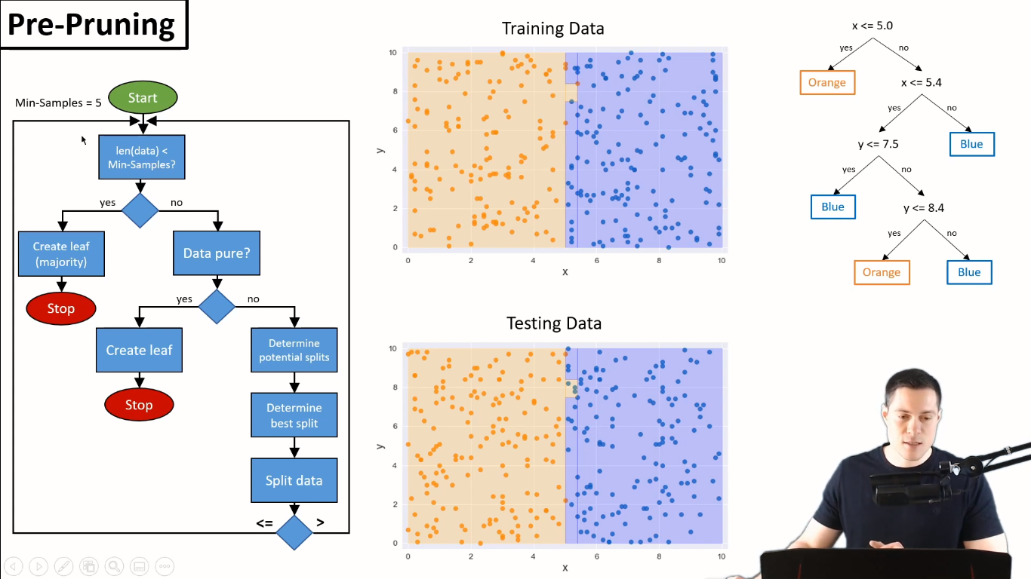

Method 2 -> depth of tree

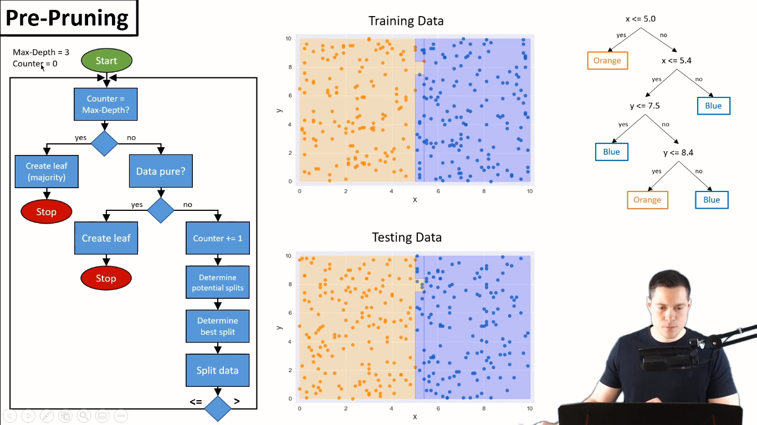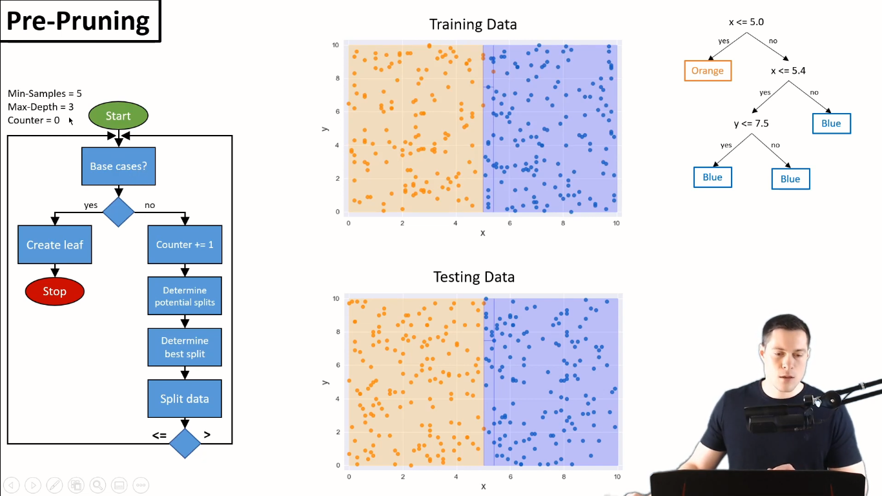

**Post pruning**

**We make tree first then we perform pruning**

Should we prun down or remain unchanged? Depends to validation data sets

Check which makes less error

If errors for leaf is less than actual decision split on validation datasets we post prun to leaf node

Reduced error pruning

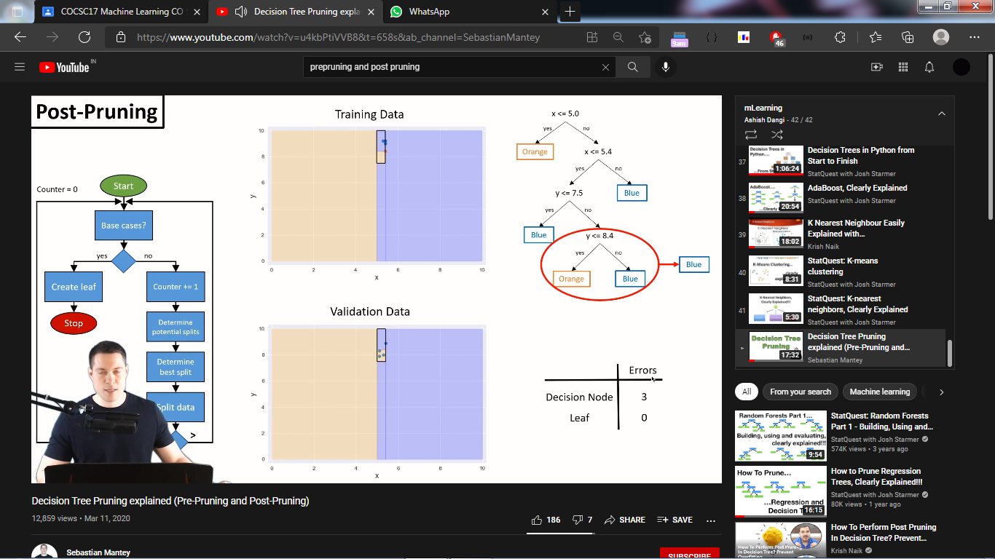

**-------------------------------------------------------------------------------------------------------------------------------------------------------------------------------------------------------------------------------------------------------------------------------------------------------------------------------------------------------------------------**

**KNN**